Stocks Manual

- Global Settings

1.1 Define Item Category

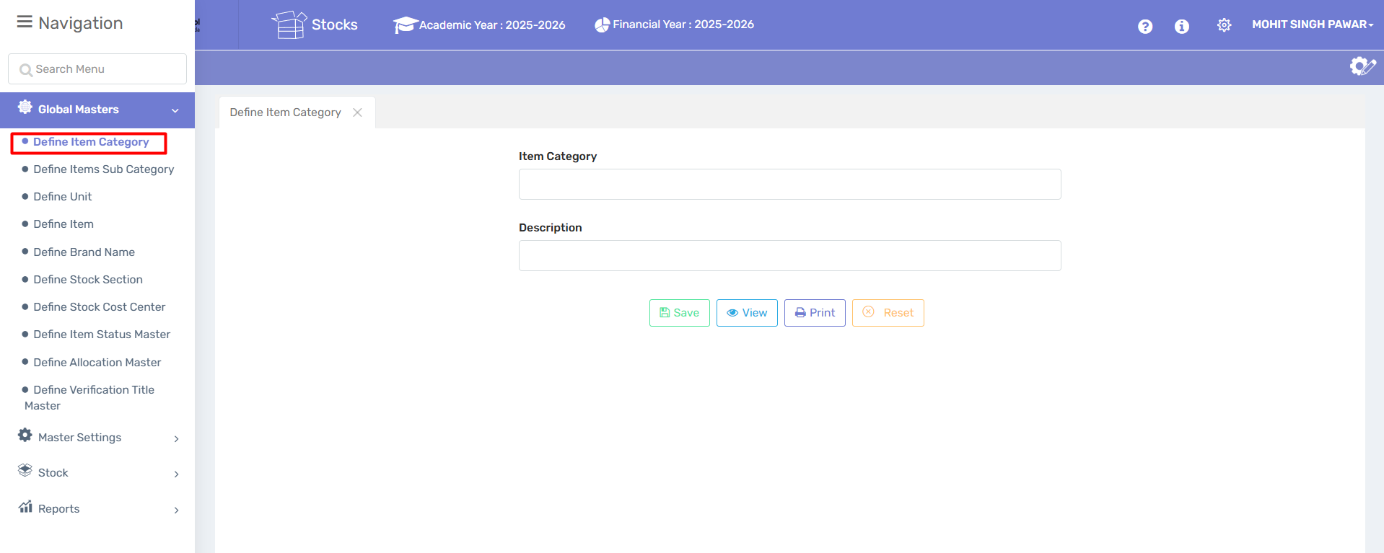

Purpose:
This form is used to define and categorize different types of items in the ERP system. Categorizing items helps in organizing, reporting, filtering, and managing inventory or product listings more efficiently.

Form Fields:
- Item Category
  - Description: Enter the name of the item category (e.g., "Electronics", "Furniture", "Office Supplies").
  - Input Type: Text field
2. Description
  - Description: Provide a brief description of the category to clarify its purpose or contents (e.g., "Includes all electronic devices and accessories").
  - Input Type: Text field

Button | Function
✅ Save | Saves the new or edited item category into the system.
👁️ View | Displays a list or details of existing item categories.
🖨️ Print | Allows you to print the current screen or item category details.
❌ Reset | Clears all input fields on the form so you can start fresh.

User Instructions:
- To Add a New Category:
  - Type a name in the Item Category field.
  - Fill in the Description.
  - Click Save.

- To View Existing Categories:
  - Click the View button.
- To Print Category Details:
  - Click the Print button after saving or selecting a category.
- To Reset the Form:
  - Click Reset to clear all fields.

1.2 Define Items Sub Category

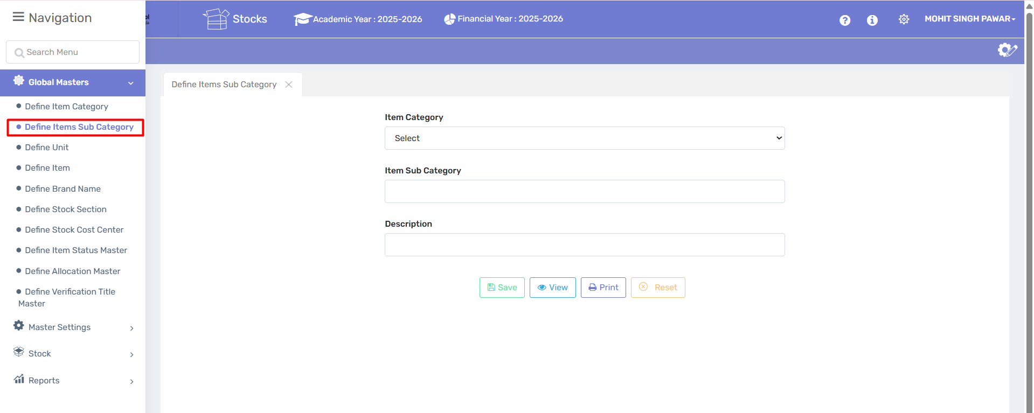

Purpose:

This page allows users to create subcategories under a main item category. It helps in further classifying inventory or product items for better tracking, reporting, and organization

Form Fields Explanation:
- Item Category
  - Type: Dropdown selection
  - Description: Select the main item category under which the subcategory will be grouped.
(e.g., If "Electronics" is selected, the subcategory could be "Laptops" or "Chargers".)
- Item Sub Category
  - Type: Text input
  - Description: Enter the name of the subcategory that fits under the selected main category.
- Description
  - Type: Text input
  - Description: Provide a short explanation or purpose of the subcategory to describe its scope or use.

Action Buttons:
Button | Description
✅ Save | Stores the subcategory in the system. Make sure all required fields are filled before clicking.
👁️ View | Opens the list or table of existing subcategories for review or selection.
🖨️ Print | Prints the current page or subcategory details, useful for recordkeeping.
❌ Reset | Clears all input fields so a new entry can be made.

User Instructions:

To Create a New Subcategory:
- Select a main Item Category from the dropdown list.
- Enter the Item Sub Category name.
- Provide a Description (optional but recommended).
- Click Save to store the new subcategory.

To View Existing Subcategories:
- Click the View button.

To Print Subcategory Details:
- Click the Print button.
To Clear the Form:
- Click Reset to clear all fields and start fresh.

1.3 Define Unit

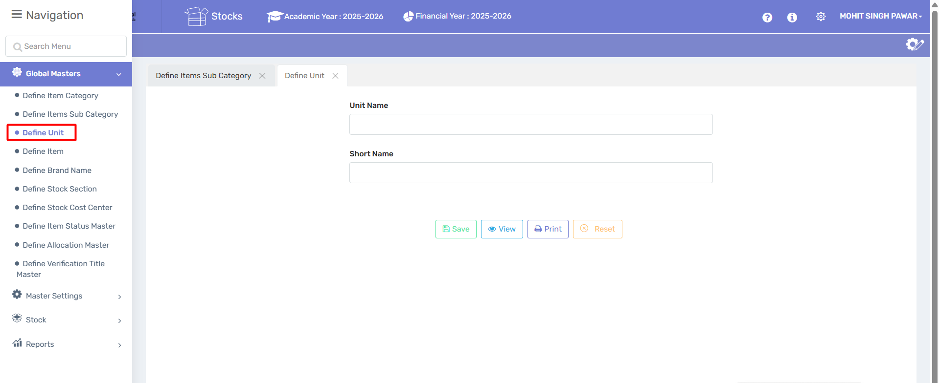

Purpose:
This page allows users to define measurement units used throughout the inventory, procurement, and stock systems. Proper unit definition ensures accurate stock control and standardization in transactions.

Form Fields Explanation:
- Unit Name
  - Type: Text input
  - Description: Enter the full name of the measurement unit.
  - Examples: Kilogram, Litre, Meter, Piece
- Short Name
  - Type: Text input
  - Description: Enter a brief abbreviation of the unit.
  - Examples: kg, ltr, m, pc

Action Buttons:
Button | Description
✅ Save | Saves the defined unit to the system for future use.
👁️ View | Opens the list of previously defined units.
🖨️ Print | Prints the list or details of unit entries.
❌ Reset | Clears all fields to allow new input.

User Instructions:

To Define a New Unit:
- Enter the full Unit Name.
- Enter the Short Name (abbreviation).
- Click Save.

To View Existing Units:
- Click the View button.

To Print Units List:
- Click the Print button.

To Clear the Form:
- Click Reset to clear all fields.

1.4 Define Item

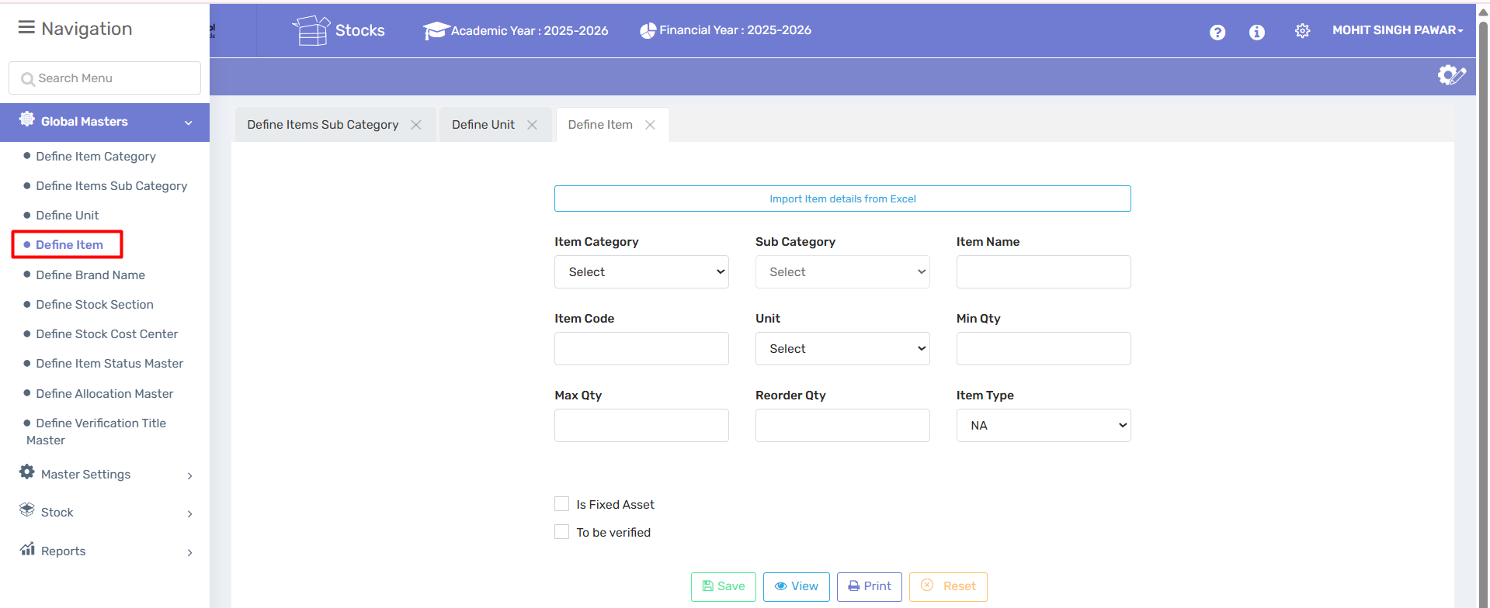

Purpose:
This page allows users to define and register inventory items in the system. Each item is categorized, assigned units, and set with quantity controls. This is essential for proper inventory tracking, reorder management, and asset control.

Form Fields Explanation:

Field Name | Description | Example
Item Category | Select the main category to which the item belongs. Must be predefined in “Define Item Category.” | Stationery, Furniture
Sub Category | Select the sub-category from predefined entries. Must be set in “Define Item Sub Category.” | Pen, Chair
Item Name | Enter the name of the item to be tracked. | Gel Pen, Wooden Table
Item Code | A unique identifier or barcode for the item (manual or auto-generated). | ST001, PEN-GEL-001
Unit | Measurement unit for the item (must be defined earlier). | Pieces, Kilograms
Min Qty | Minimum quantity required before reorder is triggered. | 10
Max Qty | Maximum quantity allowed in stock. | 100
Reorder Qty | Ideal quantity to reorder when min qty is reached. | 50
Item Type | Select the nature/type of item (e.g., Consumable, Asset, Service). | Consumable, NA
Is Fixed Asset | Checkbox to mark if the item is a fixed asset. | ✅ (for assets like projectors)
To be verified | Checkbox indicating the item needs further verification. | ✅ (for unconfirmed items)

Top Feature:
- Import Item details from Excel
  - Allows bulk import of item data using a standard Excel format.
  - Reduces manual entry and ensures consistency.
Note : Excel will upload in head office

Action Buttons:
Button | Description
✅ Save | Saves the item details to the inventory database.
👁️ View | Opens the list of all defined items for review or editing.
🖨️ Print | Prints item list or individual item details.
❌ Reset | Clears all current entries in the form to start fresh.

User Instructions:

To Define a New Item:
- Select Item Category and Sub Category.
- Fill in Item Name, Code, and Unit.
- Specify Min Qty, Max Qty, and Reorder Qty.
- Select Item Type and tick Is Fixed Asset if applicable.
- Optionally, check To be verified.
- Click Save.

To Import Multiple Items:
- Click Import Item details from Excel and upload a correctly formatted file.

1.5 Define Brand Name

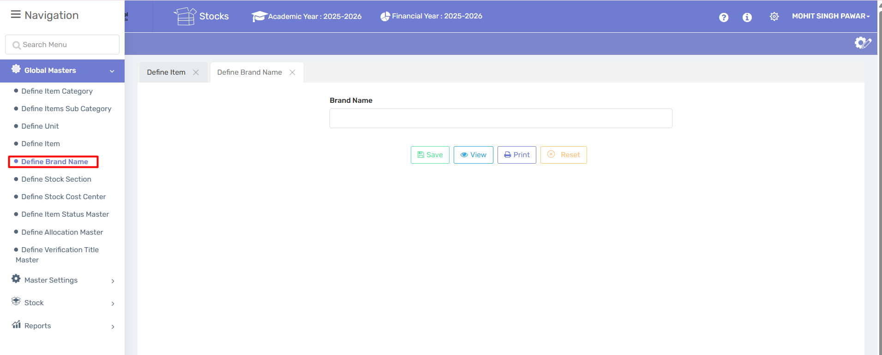

Purpose:
This screen allows users to create and manage Brand Names for stock items used within the institution. Brands help categorize items more accurately (e.g., "Classmate" notebooks, "HP" printers).

🔸 How to Use This Page:

1. Enter Brand Name
- In the Brand Name input field, type the name of the brand.
- Example: Classmate, Dell, Faber-Castell.

2. Save the Brand
- Click on the ✅ Save button to store the brand in the system.
- Once saved, this brand will become selectable in relevant modules (like "Define Item").

3. View All Brands
- Click on the 🔍 View button to see a list of all existing brands.

4. Print the List
- Use the 🖨️ Print button to generate a printable list of brand names.

5. Reset the Form
- Click on the 🔁 Reset button to clear the form and enter a new brand name.

1.6 Define Stock Section
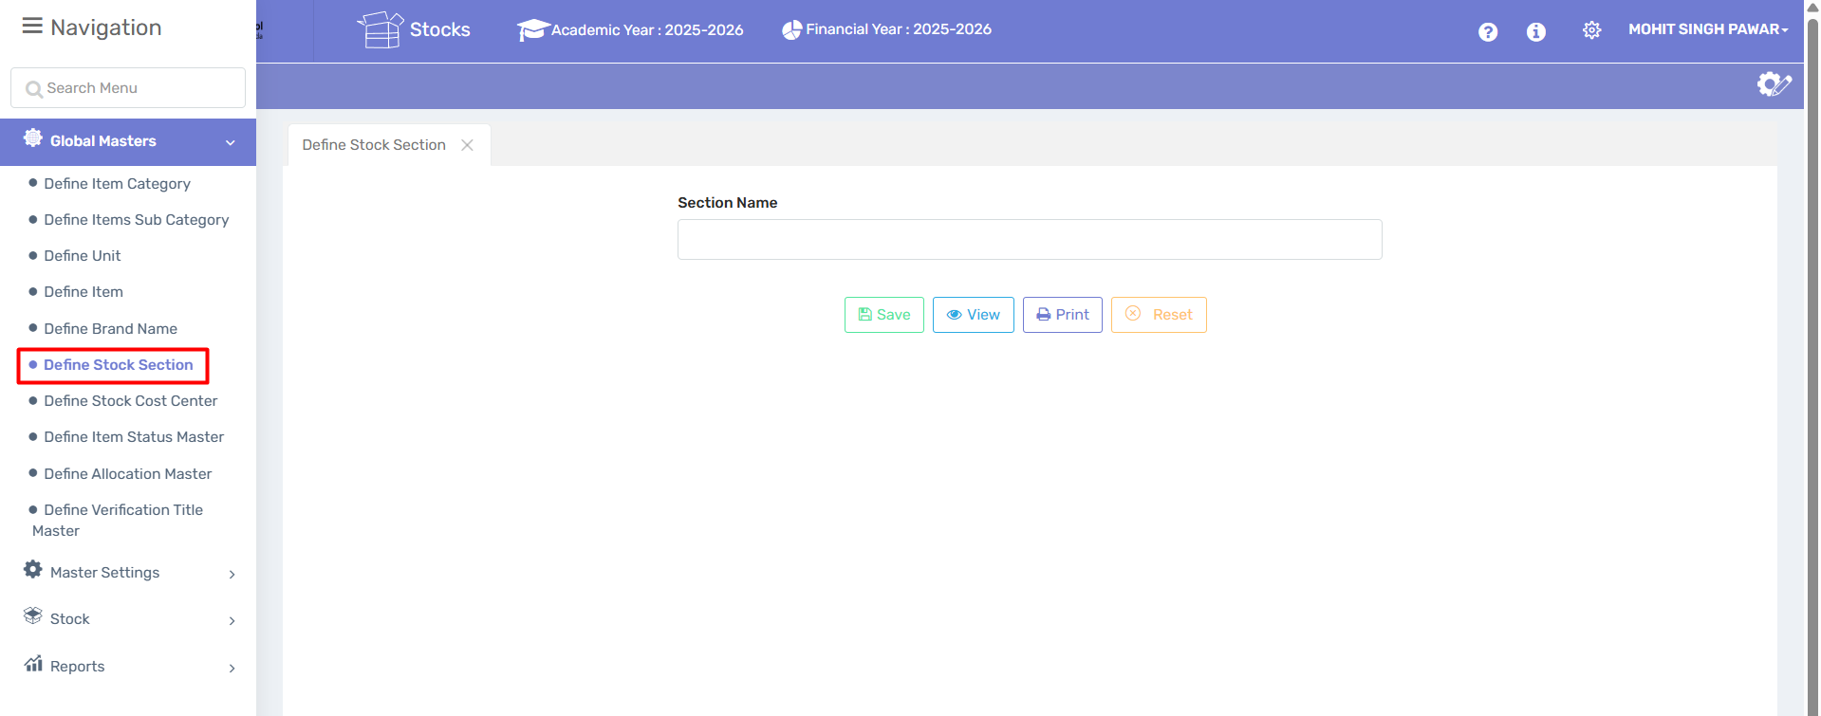

Purpose:
The Define Stock Section screen is used to create and manage different stock sections within the inventory. Sections can represent physical storage locations (like a store room, lab cupboard, library shelf) or logical divisions (e.g., Stationery, Electronics, Sports Equipment).

🔸 How to Use This Page:

1. Enter Section Name
- In the Section Name field, type the name of the stock section.
- Examples: Main Store, Stationery Shelf, Lab Equipment.

2. Save the Section
- Click the ✅ Save button to store the section in the ERP database.
- Saved sections will be used while entering or tracking items in inventory.

3. View Existing Sections
- Click the 🔍 View button to see all stock sections created so far.

4. Print Section List
- Click 🖨️ Print to generate a hard copy of all defined sections.

5. Reset the Form
- Click 🔁 Reset to clear the input and enter a new section.

1.7 Define Stock Cost Center

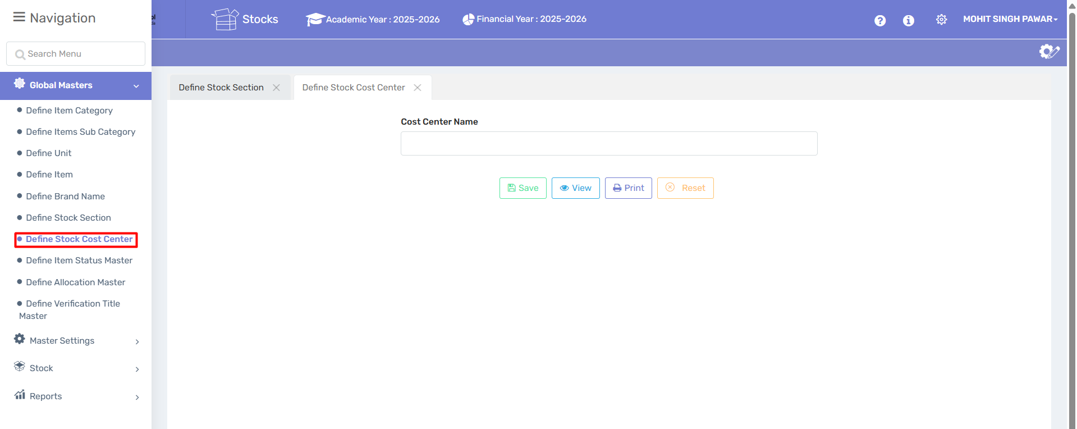

Purpose:

The Stock Cost Center refers to a department, location, or function within the organization where costs related to stock usage or procurement are tracked. This allows for better budgeting, expense management, and accountability.

🔸 How to Use This Page:

1. Enter Cost Center Name

Input the Cost Center Name (e.g., Science Lab, Admin Department, Sports Wing, Library, Cafeteria).

2. Save

Click ✅ Save to add the cost center to the system.

3. View

Click 🔍 View to display all existing cost centers.

4. Print

Click 🖨️ Print to generate a printable version of the list for reference or reporting.

5. Reset

Click 🔁 Reset to clear the form and start fresh.

1.8 Define Item Status Master

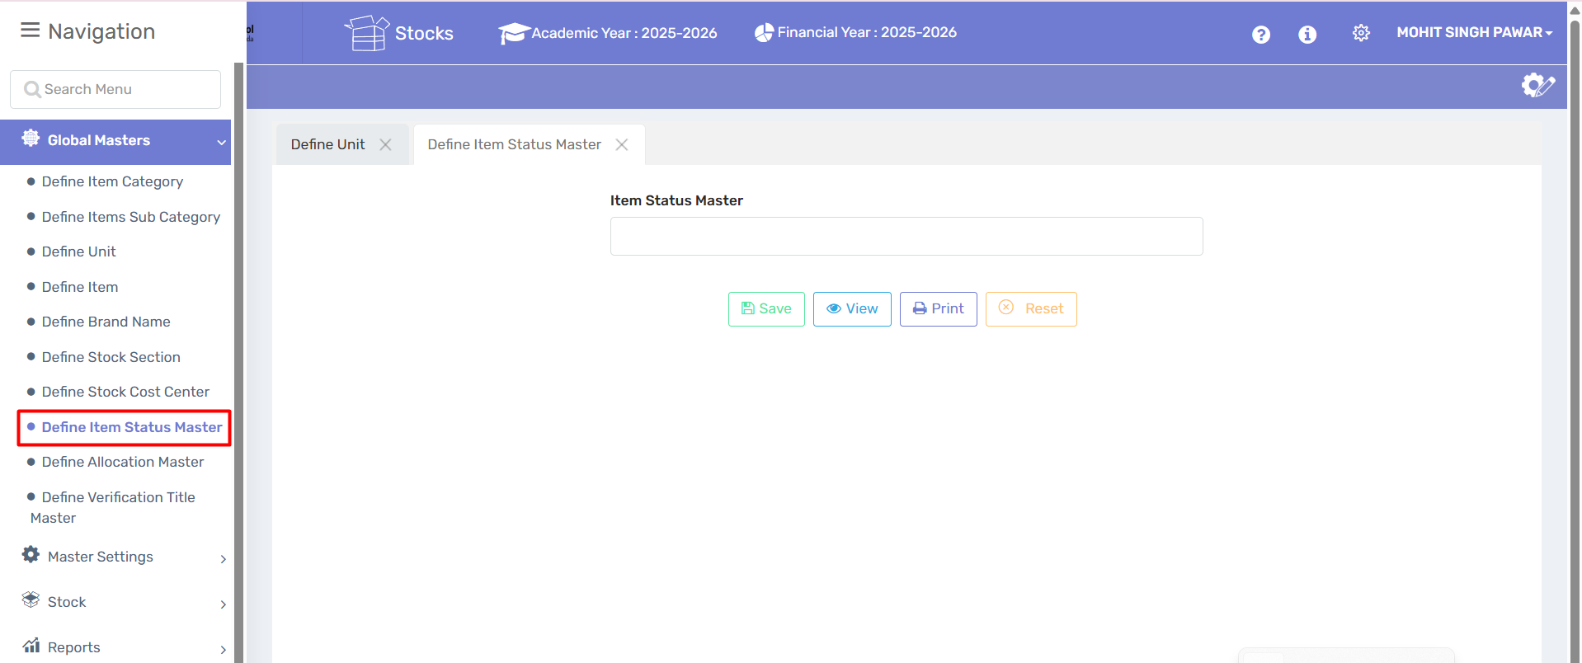
Purpose:
The Item Status Master module allows you to define various statuses for items in the inventory. These statuses indicate the condition, availability, or lifecycle stage of an item and are crucial for stock visibility and workflow clarity.

🔸 How to Use This Page:

1. Enter Item Status
- In the Item Status Master field, enter the status label for an item.
- Examples of status entries:
  - New
  - Used
  - Under Repair
  - Scrapped
  - Returned
  - Issued

2. Save
- Click ✅ Save to store the new status in the system.

3. View Existing Statuses
- Click 🔍 View to list all item statuses previously added.

4. Print Status List
- Click 🖨️ Print to generate a printable report of item statuses.

5. Reset Form
- Click 🔁 Reset to clear the entry field.
1.9 Define Allocation Master

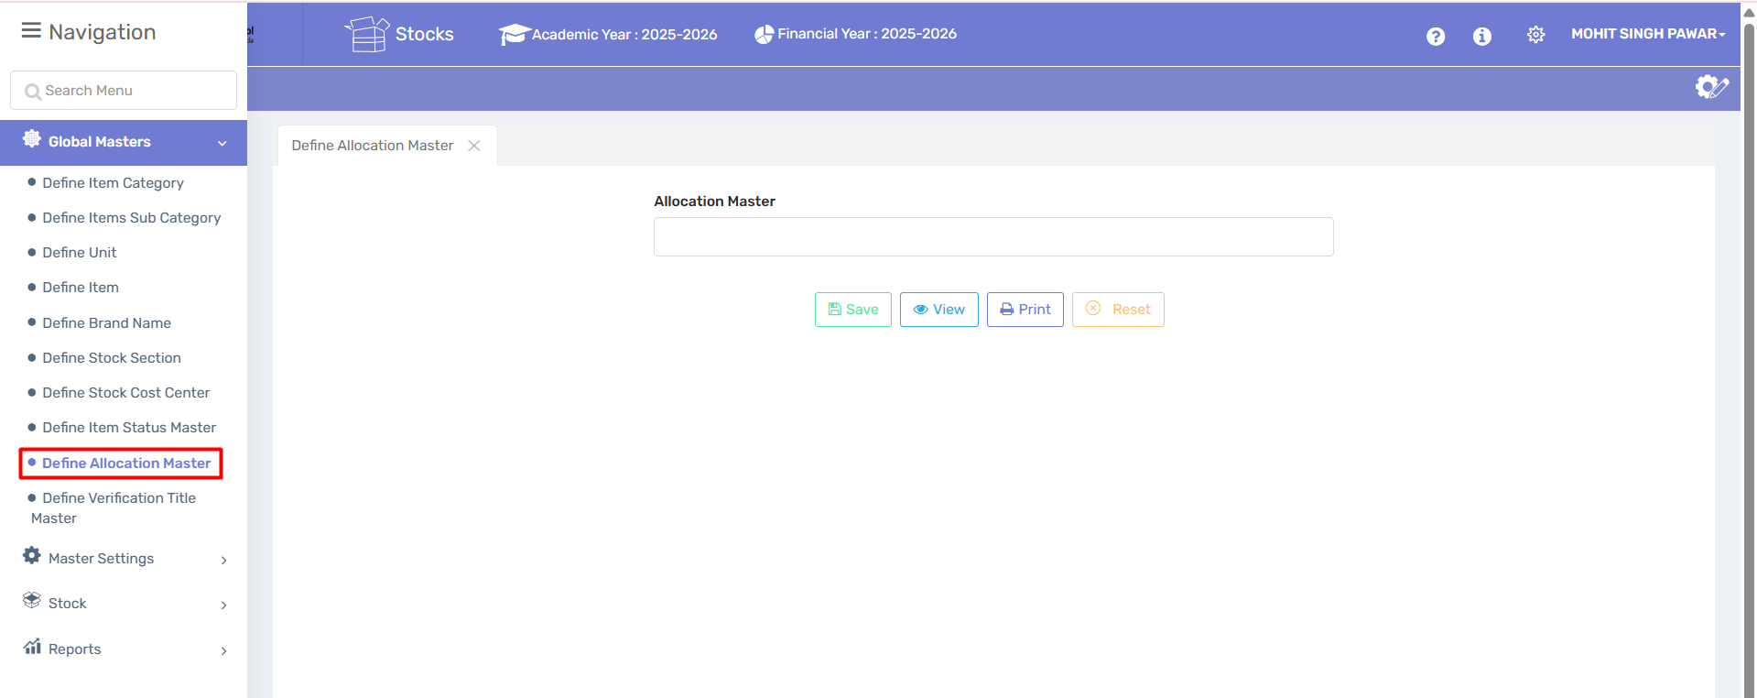

Purpose:
The Allocation Master module allows users to define and manage allocation categories used to distribute or assign stock, budgets, resources, or responsibilities. These allocations help in tracking where and how materials or costs are designated within the organization.

🔸 How to Use This Page:

1. Enter Allocation Name
- In the Allocation Master field, input the name for the allocation category.
- Examples:
  - Project A
  - Maintenance Department
  - R&D
  - IT Infrastructure

2. Save
- Click ✅ Save to record the new allocation name.

3. View Existing Allocations
- Click 🔍 View to see all allocation names defined previously.

4. Print Allocation List
- Click 🖨️ Print to generate a printable list of allocations.

5. Reset Form
- Click 🔁 Reset to clear the input field.

1.10 Define Verification Title Master

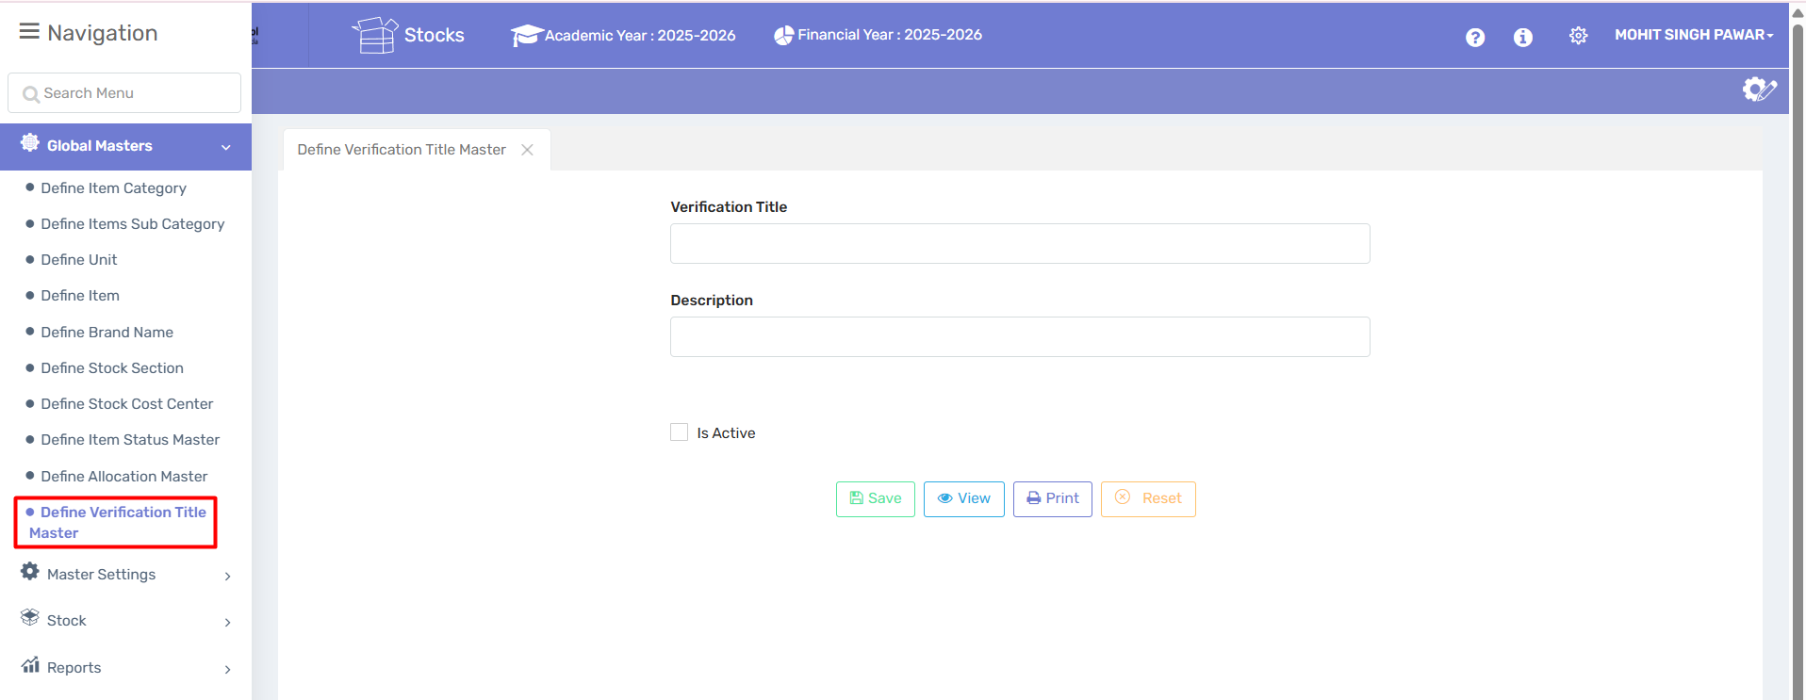
Purpose:
The Verification Title Master is used to define and manage verification checkpoints or audit titles that are part of various workflows (e.g., stock audit, inspection stages, verification procedures). These titles help track and formalize specific steps that require validation.

🔸 How to Use This Page:

1. Enter Verification Title
- Input the Verification Title (e.g., Physical Stock Check, Principal Approval, Annual Audit).

2. Enter Description
- Optionally, add a short Description to elaborate on the purpose or conditions of the verification stage.

3. Mark Active (Optional)
- Check the ✅ Is Active box to activate the title.
- Leave it unchecked if the title is not currently in use (helps retain data without cluttering dropdowns in active modules).

4. Save
- Click ✅ Save to store the new verification title.

5. View Existing Titles
- Click 🔍 View to see a list of previously defined verification titles.

6. Print Titles
- Click 🖨️ Print to generate a printable version of the list.

7. Reset Form
- Click 🔁 Reset to clear the input fields and start over.

- Master Settings

2.1 Change Academic Year

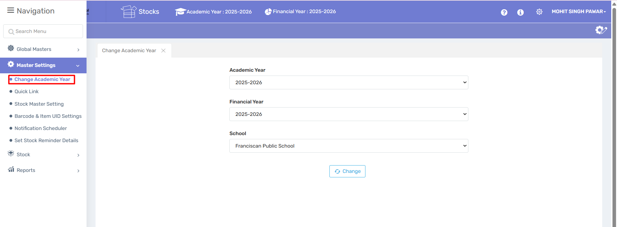

🔧 Purpose of the Module:

The "Change Academic Year" module allows administrators to update the working session (academic and financial year) in the ERP system for a selected school. This is crucial for ensuring all operations (student data, reports, admissions, fee records, etc.) reflect the correct session.
🧩 Components on the Screen:

1. Academic Year Dropdown:

Select the desired academic session (e.g., 2025–2026).

Affects student-related activities like attendance, exam reports, promotions, etc.

2. Financial Year Dropdown:

Select the applicable financial session (e.g., 2025–2026).
Important for accounting, fee records, salary processing, and budget management.

3. School Selection:

Choose the school (e.g., Franciscan Public School).

Useful in cases where the ERP is used by a group of institutions or branches.

4. Change Button:

After selecting the correct academic and financial year, click Change to apply the settings.

The system will switch the entire ERP data context to the selected session.

🔒 Who Can Use It:

Only admins or users with appropriate privileges should access this module, as changing the academic/financial year affects the whole institution's data operations.

⚠ Important Notes:
Make sure all previous year's data entries are completed before changing the year
Once changed, all entries and reports will reflect the new academic/financial year.

Double-check for fee structures, student promotions, and report card finalizations before switching.

2.2 Quick Link

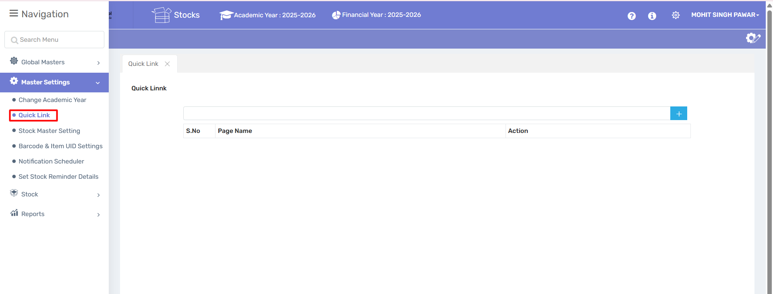
📌 Purpose of the "Quick Link" Module:

The Quick Link module allows administrators or users to create shortcuts to frequently used pages or features within the ERP. This helps in quickly accessing important or commonly used screens without having to navigate through the full menu each time.

🛠 Features Shown:

1. Quick Link Table:

Displays a list of all added quick links.

Columns include
S. No – Serial number of the entry.

Page Name – Name of the page for the shortcut.

Action – Usually includes edit or delete options.

2. Add New Quick Link:

A "+" (plus) icon on the right side allows you to add a new quick link.

Upon clicking, you will likely be asked to:

Choose a module/page from the ERP.

Give it a name or alias.

Save it for quick access.

✅ Use Case Example:

If a user frequently needs to access the "Stock Entry" page, they can create a quick link for it. Next time, they can open it directly from here without navigating through multiple menus.

2.3 Stock Master Setting

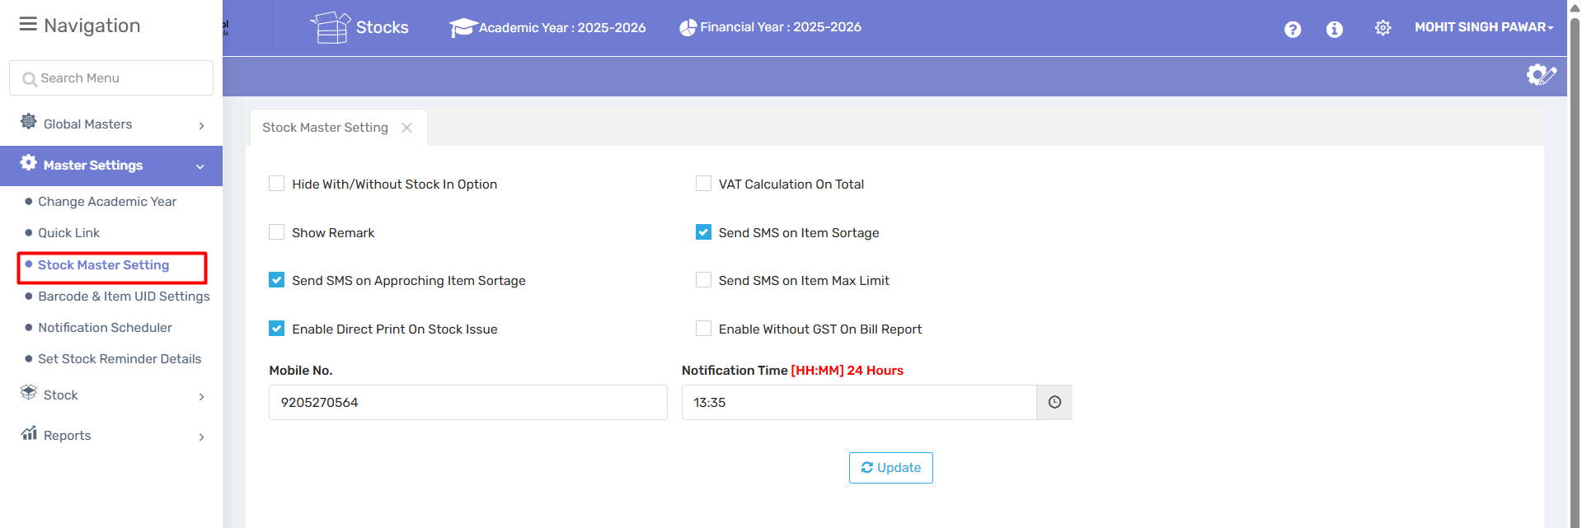
📌 Purpose of the Module:
The Stock Master Setting module is used to configure default behaviors, alerts, and SMS notifications related to stock management. These settings help automate alerts and streamline stock issue/report generation processes.

🛠 Options Explained:

1. Hide With/Without Stock In Option

Hides the filter option for items with/without stock when enabled.

2. VAT Calculation On Total

Enables VAT calculation on the total bill (if applicable).

3. Show Remark

Displays remark fields during stock operations.

4. Send SMS on Item Shortage ✅ (Checked)

Sends an SMS alert when an item is below the minimum stock level.

5. Send SMS on Approaching Item Shortage ✅ (Checked)

Sends an SMS warning when an item is about to reach shortage level.

6. Send SMS on Item Max Limit

Sends SMS if item stock exceeds a predefined maximum limit.

7. Enable Direct Print on Stock Issue ✅ (Checked)

Automatically prints the stock issue document once the stock is issued.

8. Enable without GST on Bill Report
Allows billing reports to be generated without GST details.

📱 Notification Settings:

Mobile No.: 9205270564
→ SMS notifications will be sent to this mobile number.

Notification Time: 13:35
→ Time (in 24-hour format) when daily notifications will be sent.

🔘 Action Button:

Update – Saves the current stock settings.

✅ Use Case:

Suppose an item like "Printer Ink" is about to run out — this module ensures the responsible person gets an SMS alert at 1:35 PM so they can take timely action.

2.4 Barcode and Item UID Settings

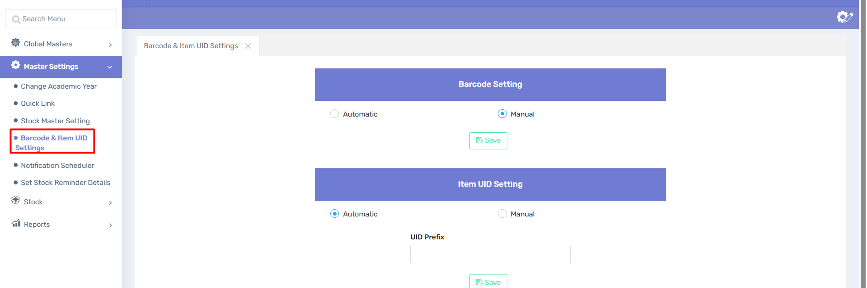

📌 Purpose of the Module:

This module is used to configure how barcodes and unique item IDs (UIDs) are generated and managed for stock items. It helps in accurate inventory tracking and item identification.

🛠 Sections and Options Explained:

1. Barcode Setting:

You can choose how barcodes are assigned to items:

Automatic: The system will auto-generate barcodes when new items are added.

Manual ✅ (Selected in image): The user must manually assign barcodes to each item.

Save Button: To apply the selected barcode setting.

2. Item UID Setting:

UID = Unique Identification Number for each item (used internally to track specific stock units).

Options:

Automatic ✅ (Selected in image): System will auto-generate unique IDs.

Manual: You have to enter UIDs manually for each item.

UID Prefix Field:
Allows you to set a prefix (e.g., "STK-", "LIB-", etc.) that will be added before each automatically generated UID.

Save Button: To save the UID setting and prefix.

✅ Use Case Example:

For a school managing lab inventory:

Automatic UID: Ensures every microscope or test tube has a distinct trackable ID like SCI-001.

Manual Barcode: Staff may scan or enter barcode labels printed externally.

2.5 Notification Scheduler
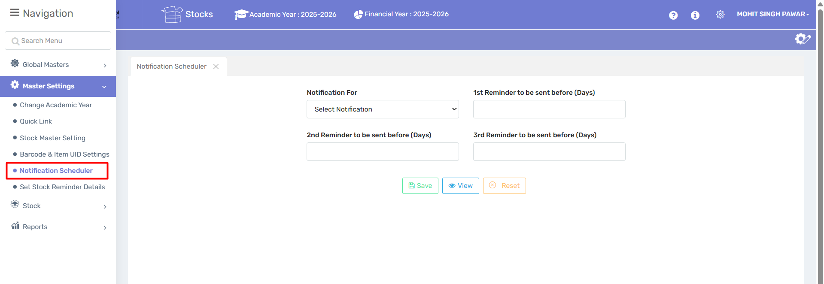
🔍 Purpose:

To schedule notifications in advance, so that users are reminded before important deadlines or events (e.g., stock expiry, reorder dates, audits, etc.).

🧩 Key Components:

1. Notification For:

Dropdown to select the type of notification (e.g., stock expiry, reorder, AMC renewal, etc.).

2. 1st Reminder to be sent before (Days):
Set how many days before the event the first reminder should be sent.

3. 2nd Reminder to be sent before (Days):

Optional second reminder, again in advance of the event.

4. 3rd Reminder to be sent before (Days):

Optional third reminder, closer to the event.

5. Buttons:

✅ Save: To save the schedule.

🔍 View: To view existing schedules.

🔄 Reset: To clear the current inputs.

✅ Benefits:

Ensures timely action on critical stock or ERP activities.

Reduces manual follow-up.

Prevents missed deadlines (e.g., purchase orders, AMC renewals).

Improves efficiency and accountability.

2.6 Set Stock Reminder details

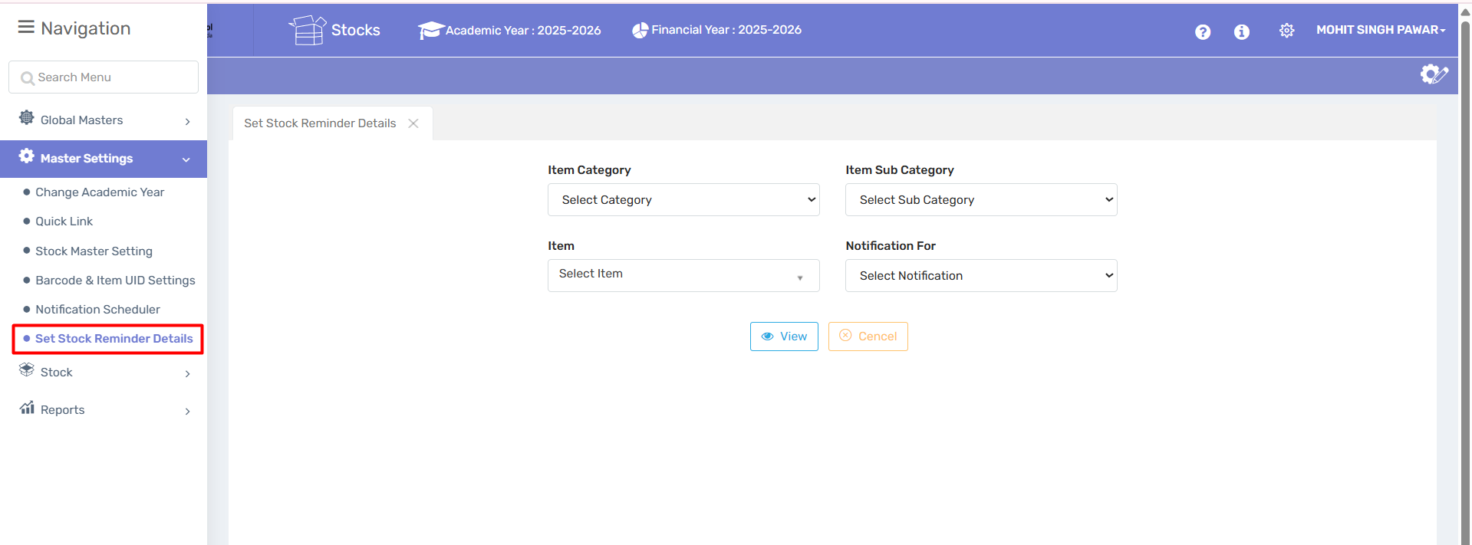

Description:
This Set Stock Reminder Details module allows users to configure automated notifications for low stock items. Here’s its purpose and workflow:

✅ Purpose:
It is designed to help manage inventory proactively. By setting reminders for specific items, it ensures you never run out of stock without prior notice.

🔄 Main Features:

1. Item Category:
Choose the main category of items (e.g. stationery, electronics, etc.).

2. Item Sub Category:
Refine the selection by specifying a sub-category for more granular control.

3. Item Selection:
Pick the specific item you want to monitor.

4. Notification For:
Define the type of notification you’d like to receive — for example, when the stock reaches a threshold.

🖱 Actions:
View:
Displays the currently configured stock reminders.

Cancel:
Clears the current selection or operation.

- Stock

3.1 Assign Opening Entry

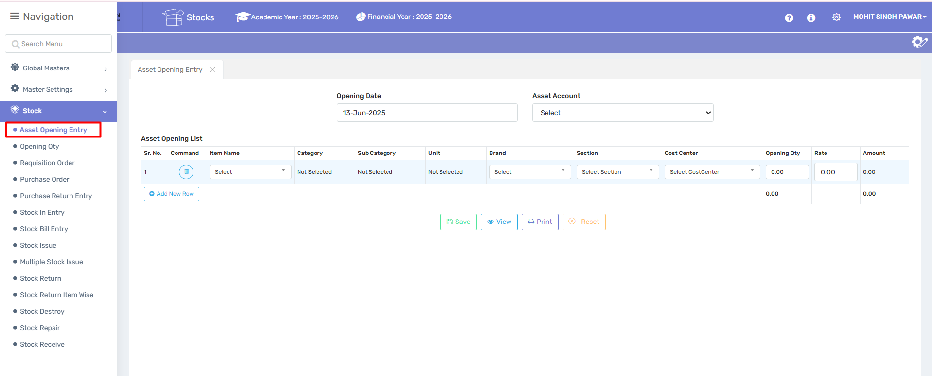
The Asset Opening Entry module allows the school or institution to record the initial balances of assets (e.g., furniture, equipment, electronics, etc.) as of the beginning of a financial year. This ensures the ERP system accurately reflects current assets and their values for reporting and inventory control.
🔸 How to Use:

1. Opening Date
- Default or manually selected date when asset records are being initialized.
Example: 16-Jun-2025.

2. Asset Account
- Select the appropriate asset ledger account (e.g., Furniture, Lab Equipment).
- This links the entry to your financial reports.
📋 Asset Opening List – Entry Fields
Each row allows entry of one asset. You may add multiple assets by clicking “Add New Row.”
Field Name | Description
Sr. No. | Serial number (auto-generated).
Command | Use the trash icon (🗑️) to delete the row.
Item Name | Choose the asset item from the dropdown.
Category / Sub Category | Auto-filled or selected based on the item type.
Unit | Specify unit of measurement (e.g., pieces, sets).
Brand | Optional – specify asset brand.
Section | Select the department (e.g., Library, Science Lab).
Cost Center | Choose a cost center if required for budgeting or departmental accounting.
Opening Qty | Enter how many units of the item exist.
Rate | Rate per unit of the item.
Amount | Auto-calculated (Qty × Rate).

🔘 Buttons and Functions
Button | Function
✅ Save | Saves all entered data into the system.
🔍 View | Displays previously saved asset opening entries.
🖨️ Print | Print the list for physical recordkeeping.
🔁 Reset | Clears the form to allow fresh entry.

📝 Notes:
- Make sure each asset item is correctly classified under the appropriate account, section, and cost center.
- Avoid duplicate entries.
- All fields marked mandatory must be filled to ensure valid data is stored.
- Total quantity and amount are auto-summed at the bottom for all rows.

3.2 Opening Qty
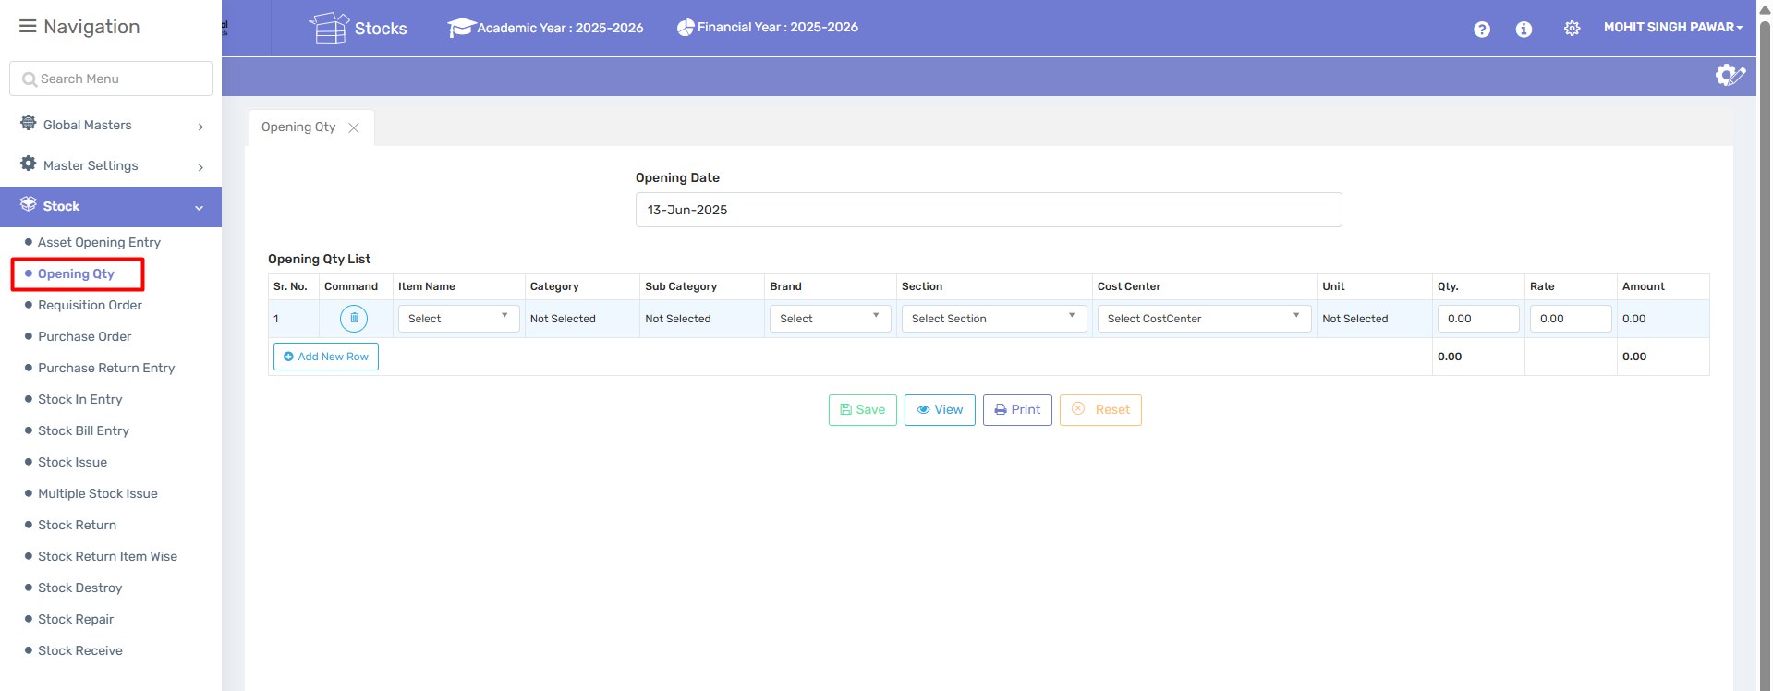

Purpose:
This page allows users to enter the opening stock quantity of items in the system as of a specific date. It is typically used at the beginning of a financial year or when migrating to a new ERP system.

🖥️ Page Components:

1. Opening Date
- Field: Opening Date
- Purpose: Select the date from which the opening stock will be recorded.
- Format: DD-MMM-YYYY (e.g., 20-Jun-2025)

2. Opening Qty List Table
This is the main section to input item-wise opening stock details.
Column | Description
Sr. No. | Serial number of the row. Auto-generated.
Command | Allows you to delete the row (trash icon).
Item Name | Dropdown to select the item for which opening stock is being entered.
Category | Auto-filled or selectable category of the item.
Sub Category | Sub-category of the item (optional or dependent on category).
Brand | Brand of the item (if applicable).
Section | Department or section where the item is used/stored.
Cost Center | Select the relevant cost center (financial unit/department).
Unit | Unit of measurement (e.g., pcs, kg, ltr).
Qty. | Quantity of the item available as opening stock.
Rate | Rate per unit.
Amount | Auto-calculated as Qty × Rate.
🔵 Add New Row: Click to enter another item line.

3. Total
- Shows the total quantity and value of all rows at the bottom of the table.

🛠️ Action Buttons:
Button | Function
💾 Save | Saves the opening stock data.
👁️ View | Lets you view existing entries.
🖨️ Print | Prints the entered data.
✖️ Reset | Clears the form to start again.

✅ Notes:
- All mandatory fields must be selected/entered before saving.
- Quantity and Rate fields must be numeric.
- Make sure the date and cost center are accurate to avoid accounting errors.
- This data may be locked after a certain date depending on your ERP’s configuration.

3.3 Requisition order

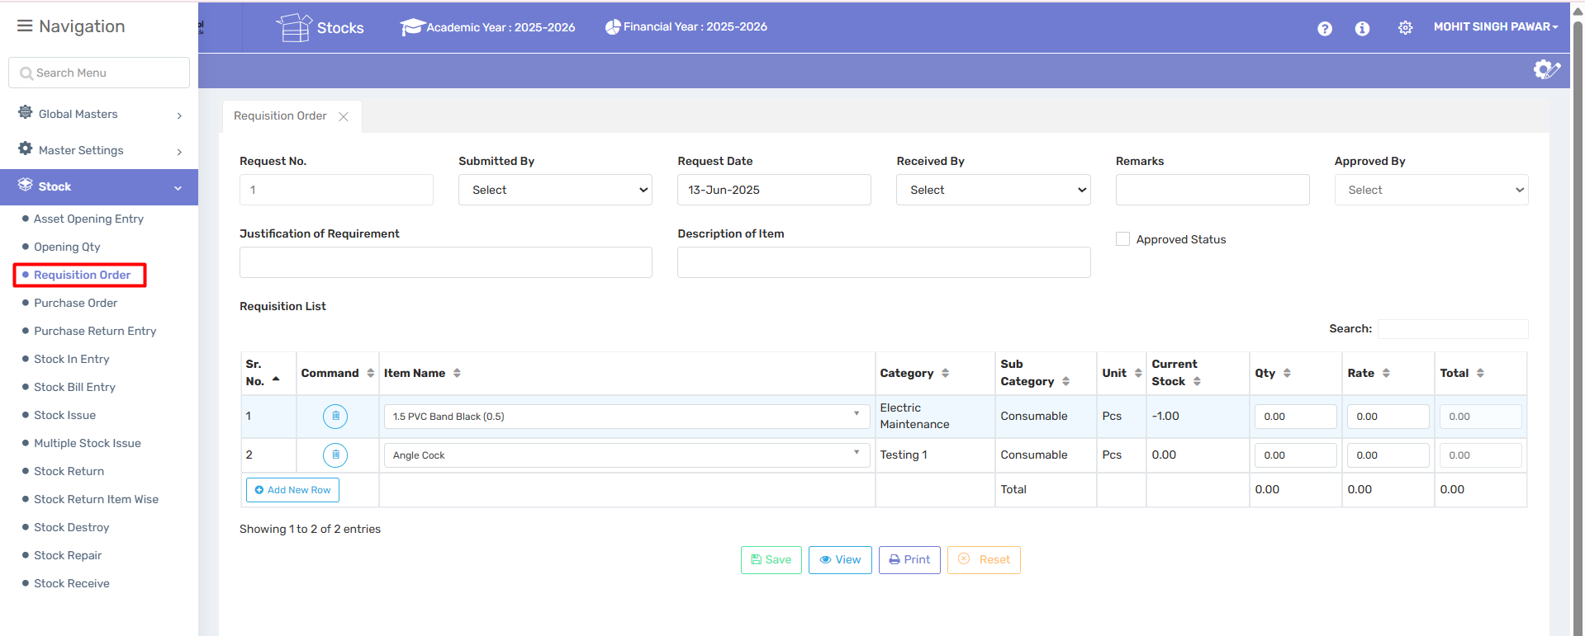

Purpose:
This page is used for raising a material requisition request when a department or user needs certain items. It helps track internal stock movement and purchase requirements.

🖥️ Page Components:

🧾 Header Section:
Field | Description
Request No. | Auto-generated or manually entered unique identifier for the requisition.
Submitted By | Name of the person/department raising the request (select from dropdown).
Request Date | Date of the requisition entry.
Received By | Person/department meant to receive the items.
Remarks | Optional field for comments or special instructions.
Approved By | Person/authority who will approve the request (dropdown).
Approved Status | Checkbox to indicate whether the requisition has been approved.

📝 Justification & Description:
Field | Description
Justification of Requirement | Reason why the item(s) are being requested (e.g., repair, replacement, new setup).
Description of Item | Any detailed information or clarification about the item(s) listed below.

📋 Requisition List Table:
This is where you list the items being requested.
Column | Description
Sr. No. | Serial number for item rows. Auto-incremented.
Command | Delete icon to remove a row.
Item Name | Select the name of the item needed.
Category | The item’s category (e.g., Electric Maintenance, Plumbing).
Sub Category | The subcategory (e.g., Consumable, Tools).
Unit | Unit of measure (e.g., pcs, meter, liter).
Current Stock | Shows the current quantity available in stock (negative values indicate shortage).
Qty | Quantity required by the requester.
Rate | Rate per unit (optional or filled automatically depending on configuration).
Total | Automatically calculated as Qty × Rate.
🔵 Add New Row: Click to add more items to the requisition.
🔍 Search: Helps in filtering/searching specific items within the list.

➕ Summary Section:
- Shows the total quantity, total rate, and total value of the entire requisition list at the bottom.

🛠️ Action Buttons:
Button | Function
💾 Save | Save the requisition entry.
👁️ View | View saved requisition orders.
🖨️ Print | Print the requisition form.
✖️ Reset | Clears all fields to start fresh.

✅ Notes:
- You must fill all required fields before saving.
- Negative current stock indicates an urgent requirement or shortage.
- Approver selection and status checkbox are used to control purchase authorization.
- Use clear justification to speed up approval and avoid rejection.

3.4 Purchase Order

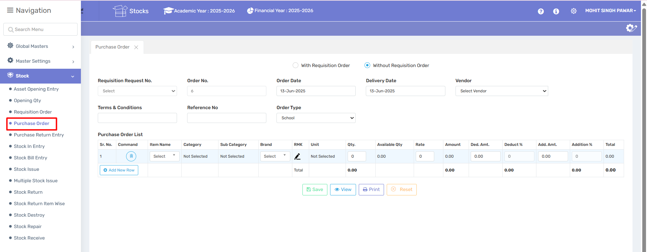

📌 Purpose:
This page is used to generate and manage purchase orders (POs) for vendors, either based on requisition requests or directly (without requisition). It helps in controlling purchases and maintaining records of procurement transactions.

🖥️ Page Components:

🔘 Purchase Order Mode:
- With Requisition Order: Links this purchase to an internal requisition request.
- Without Requisition Order: Used when making a direct purchase without any prior request.

🧾 Header Section:
Field | Description
Requisition Request No. | Select if the PO is linked to an approved requisition (enabled if "With Requisition Order" is selected).
Order No. | Unique identifier for the Purchase Order (auto or manually entered).
Order Date | Date on which the PO is created.
Delivery Date | Expected date by which goods/services should be delivered.
Vendor | Select the vendor/supplier from the dropdown list. Data will be defined under Party Legder.
Terms & Conditions | Enter purchase-related terms, payment terms, delivery terms, etc.
Reference No. | Optional field to enter any internal/external reference.
Order Type | Select order category (e.g., School, Office, Maintenance, etc.).

📋 Purchase Order List Table:
This section is used to list and define the details of each item being ordered.
Column | Description
Sr. No. | Auto-generated serial number.
Command | Delete icon to remove the row.
Item Name | Select the item being purchased.
Category / Sub Category | Classify the item for reporting/tracking.
Brand | Specify the item’s brand (if needed).
RMK (Remark) | Additional notes or comments for this item.
Unit | Unit of measurement (e.g., pcs, box, liter).
Qty. | Quantity to be purchased.
Available Qty | Current stock available in the system (for reference only).
Rate | Rate per unit.
Amount | Auto-calculated: Qty × Rate.
Ded. Amt. | Any fixed discount amount.
Deduct % | Percentage discount.
Add. Amt. | Any fixed addition (e.g., packaging).
Addition % | Percentage addition (e.g., taxes, surcharge).
Total | Final amount after applying all additions and deductions.
🔵 Add New Row: Click this button to add more items to the order.

📊 Summary Section:

At the bottom of the table, total quantities and values (Amount, Deduction, Addition, and Grand Total) are shown.

🛠️ Action Buttons:
Button | Function
💾 Save | Saves the purchase order.
👁️ View | Allows viewing existing POs.
🖨️ Print | Print a copy of the PO.
✖️ Reset | Clears the form for fresh entry.

✅ Notes:
- Select "Without Requisition Order" only if there’s no internal request.
- All financial fields (Rate, Deduct %, Add %) must be numeric.
- The total amount will reflect real-time as you enter quantities and rates.
- The vendor must be selected before saving the PO.
- It is advisable to clearly mention Terms & Conditions for legal clarity.

3.5 Purchase Return Entry

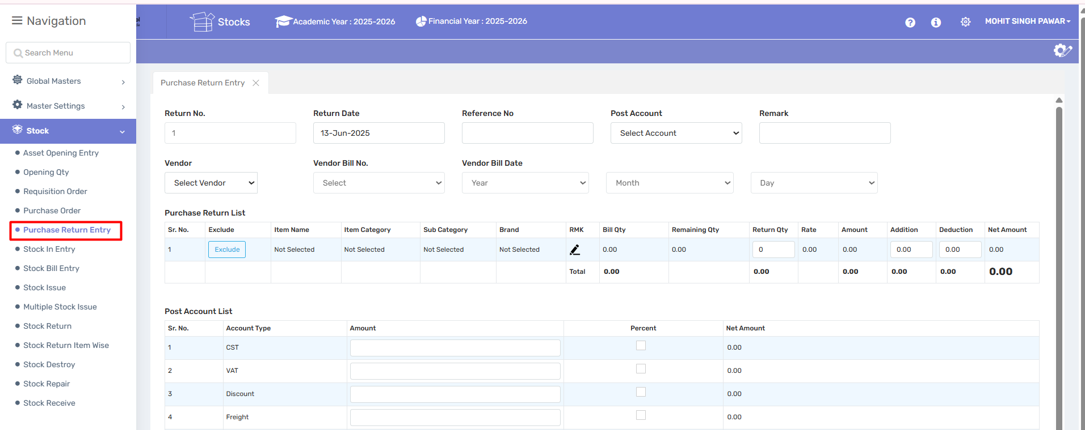

📌 Purpose:
This page is used to record purchase returns—items that are being sent back to the vendor due to damage, excess quantity, wrong supply, or other reasons. It adjusts stock and accounting records accordingly.

🖥️ Page Components:

🧾 Header Section:
Field | Description
Return No. | Unique number for tracking the return transaction (auto or manual).
Return Date | Date of the return entry.
Reference No. | Optional field for invoice or document reference.
Post Account | Select the account to which the return is posted (e.g., Purchase Return Account).
Remark | Enter any notes or explanation for the return.
Vendor | Select the vendor from whom the item was purchased.
Vendor Bill No. | Reference number of the original vendor bill/invoice.
Vendor Bill Date | Original bill date (select year, month, and day).

📋 Purchase Return List:
This table is used to list the items being returned.
Column | Description
Sr. No. | Serial number of the row.
Exclude | Click "Exclude" if a row should not be included in the final calculation.
Item Name | Select the item being returned.
Item Category / Sub Category | Classification of the item.
Brand | Brand of the item.
RMK (Remark) | Enter notes or details about the item.
Bill Qty | Quantity from the original purchase bill.
Remaining Qty | Available quantity that can still be returned.
Return Qty | Quantity you are returning.
Rate | Rate per unit.
Amount | Calculated as Return Qty × Rate.
Addition / Deduction | Any additional charge or deduction.
Net Amount | Final amount after additions/deductions.
🔹 Total row at the bottom calculates the sum of all return items.

💰 Post Account List:
Used to handle financial adjustments (like taxes, discounts, freight, etc.) associated with the return.
Column | Description
Account Type | Predefined financial heads (CST, VAT, Discount, Freight, Other).
Amount | Manually entered fixed value for each account type.
Percent | Tick the checkbox if the entered amount is a percentage instead of a fixed amount.
Net Amount | Automatically calculated final value after applying logic.

🛠️ Notes:
- You must select a vendor before saving the entry.
- Use the “Exclude” button to ignore wrongly added rows.
- Ensure the Return Qty does not exceed the Remaining Qty.
- Adjustments in the Post Account List affect the final accounting values.
- Always double-check rate and amount for accuracy before saving.

3.6 Stock In Entry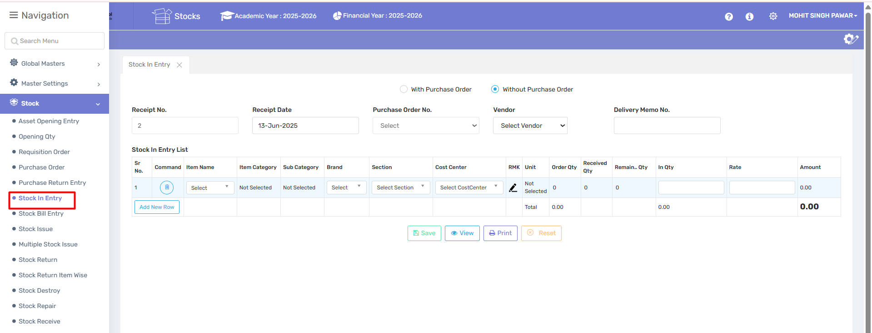

📌 Purpose:
This page is used to record the receipt of items into inventory, either against a purchase order or directly (without a purchase order). It updates the stock levels in the system and supports material inward documentation.

🖥️ Page Components:

🔘 Entry Mode:
- With Purchase Order: Use when stock is received based on an approved purchase order.
- Without Purchase Order: Use for direct material receipt (donation, samples, urgent buying, etc.).

🧾 Header Section:
Field | Description
Receipt No. | Auto-generated or manually entered receipt number for tracking.
Receipt Date | Date on which stock is physically received.
Purchase Order No. | Select the PO from which items are received (if applicable).
Vendor | Select the vendor/supplier from the dropdown.
Delivery Memo No. | Reference number of delivery challan or memo provided by the vendor.

📋 Stock In Entry List:
This table is where item-level receipt details are entered.
Column | Description
Sr. No. | Serial number of each item line.
Command | Trash icon to delete the row.
Item Name | Select the item being received.
Item Category / Sub Category | Classification of the item.
Brand | Brand name, if applicable.
Section | Department or store where the item is being received.
Cost Center | Financial division for which the item is being received.
RMK (Remark) | Any notes or remarks regarding the item.
Unit | Unit of measurement (e.g., pcs, box, kg).
Order Qty | Quantity originally ordered (auto-filled if PO linked).
Received Qty | Quantity already received till date.
Remaining Qty | Quantity still pending receipt.
In Qty | Quantity now being received in this entry.
Rate | Rate per unit.
Amount | Auto-calculated: In Qty × Rate.
🔹 Total Row: Shows total amount value of the stock-in transaction.

🛠️ Action Buttons:
Button | Function
💾 Save | Saves the stock-in entry.
👁️ View | View existing saved entries.
🖨️ Print | Print the receipt or inward register.
✖️ Reset | Clear all entries to start afresh.

✅ Notes:
- If the stock is received without PO, you can manually enter item and quantity.
- If linked to a PO, most details like Order Qty and Rate auto-fill.
- Use “In Qty” to record the exact quantity received in this delivery.
- This entry affects stock levels and financial posting depending on system settings.

3.7 Stock Bill Entry

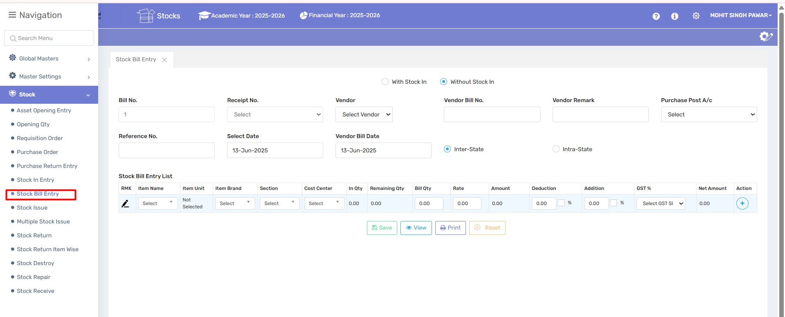

📌 Purpose:
This page is used to record vendor invoices (bills) for goods received—whether those goods were entered in the system via Stock In Entry or not. It links stock transactions with vendor billing and supports accounting, tax, and payment processes.

🖥️ Page Components:

🔘 Entry Mode:
- With Stock In: Use this if the bill is against an already received stock entry (Receipt No. is required).
- Without Stock In: Use this when the bill is for items directly billed without stock entry (e.g., services, advance invoicing, or manual inward).

🧾 Header Section:
Field | Description
Bill No. | Internal bill number for tracking (auto/manual).
Receipt No. | Select stock receipt number if linked with Stock In (active only when "With Stock In" is selected).
Vendor | Select the vendor issuing the bill.
Vendor Bill No. | The bill/invoice number provided by the vendor.
Vendor Remark | Any special instructions or notes from the vendor.
Purchase Post A/c | Account under which the purchase will be posted (e.g., Inventory A/c, Purchase A/c).
Reference No. | Internal reference number or linked order ID.
Select Date | Date of stock bill entry.
Vendor Bill Date | Date mentioned on the vendor's invoice.
Inter/Intra-State | Select based on whether the transaction is interstate or within the same state (used for tax/GST rules).

📋 Stock Bill Entry List:
This section details the items in the bill.
Column | Description
RMK (Remark) | Any item-specific remark.
Item Name | Name of the item being billed.
Item Unit | Unit of measurement.
Item Brand | Brand name (if applicable).
Section | Department or location receiving the item.
Cost Center | Financial unit or budget heading.
In Qty | Quantity entered in Stock In (if applicable).
Remaining Qty | Quantity still pending for billing.
Bill Qty | Quantity to be billed.
Rate | Per unit rate.
Amount | Auto-calculated: Bill Qty × Rate.
Deduction | Any discount (can be % or fixed amount).
Addition | Extra charges (like freight, packaging).
GST % | GST rate applied (select from dropdown).
Net Amount | Final payable amount after tax, deductions, and additions.

🛠️ Action Buttons:
Button | Function
💾 Save | Saves the stock bill entry.
👁️ View | View past bill entries.
🖨️ Print | Print bill entry for audit or record.
✖️ Reset | Clears all fields for a new entry.

✅ Notes:
- Inter/Intra-State selection affects GST applicability (CGST/SGST vs IGST).
- Ensure the Purchase Post A/c is selected for correct ledger posting.
- Validate all amounts before saving—especially if bill is without stock in.
- Stock-linked billing ensures traceability; use "Without Stock In" carefully for manual entries only.

3.8 Stock Issue

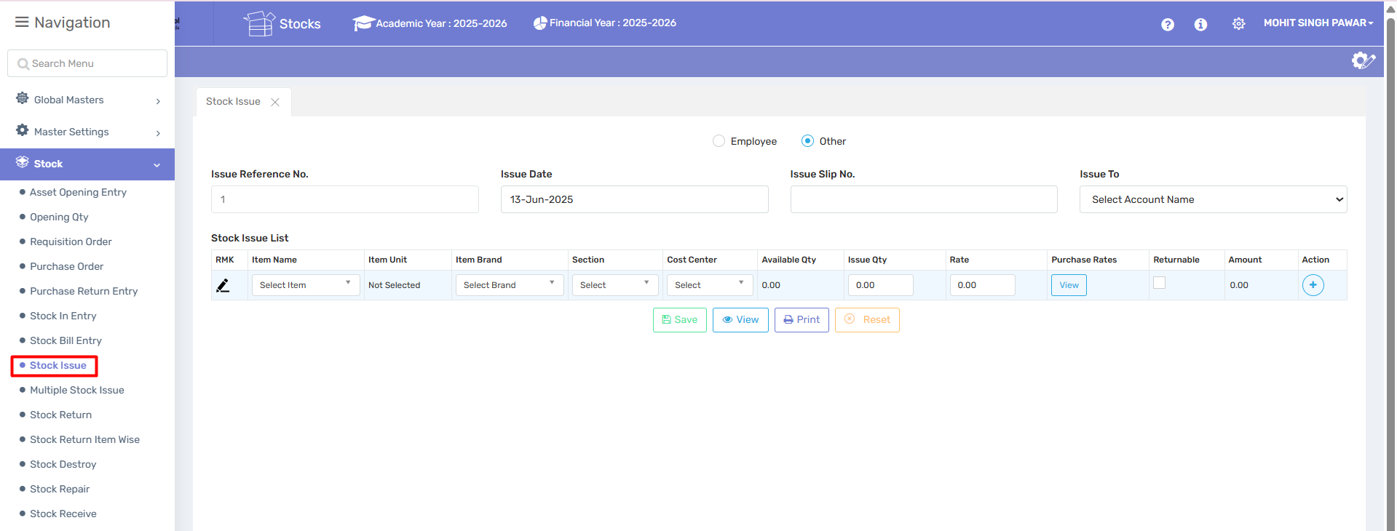

📌 Purpose:
This page is used to issue stock items (materials/supplies) to employees, departments, or other entities. It reduces inventory and helps in tracking material usage and responsibility.

🖥️ Page Components:

🔘 Issue Type:
- Employee: Choose this when issuing materials to specific personnel.
- Other: Use this when issuing items to departments, projects, or cost centers.

🧾 Header Section:
Field | Description
Issue Reference No. | Auto/manual number for tracking the issue transaction.
Issue Date | Date of stock issuance.
Issue Slip No. | Optional field for entering physical issue slip number or gate pass.
Issue To | Select the recipient (employee name, department, project, etc.).

📋 Stock Issue List:
This table lists items being issued from stock.
Column | Description
RMK (Remark) | Use the pencil icon to enter notes or details for that item.
Item Name | Select the item being issued.
Item Unit | Unit of measurement (e.g., pcs, box, meter).
Item Brand | Brand or make of the item.
Section | Department from which item is issued.
Cost Center | Financial or project head responsible for the cost.
Available Qty | Quantity currently available in stock.
Issue Qty | Quantity you wish to issue now.
Rate | Per unit cost for reference.
Purchase Rates | Click "View" to check historical purchase rates.
Returnable | Tick this checkbox if the item is returnable (like tools, equipment).
Amount | Auto-calculated as Issue Qty × Rate.
Action | Use "+" to add a new item row.

🛠️ Action Buttons:
Button | Function
💾 Save | Save the stock issue entry.
👁️ View | View past issue entries.
🖨️ Print | Print issue slip for documentation.
✖️ Reset | Clear the form to make a fresh entry.

✅ Notes:
- Ensure stock is available before entering "Issue Qty".
- Track returnable items properly to maintain accountability.
- Proper use of the Cost Center helps in budgeting and expense tracking.
- Make sure the Rate reflects actual purchase cost or issue price.

3.9 Multiple Stock Issue

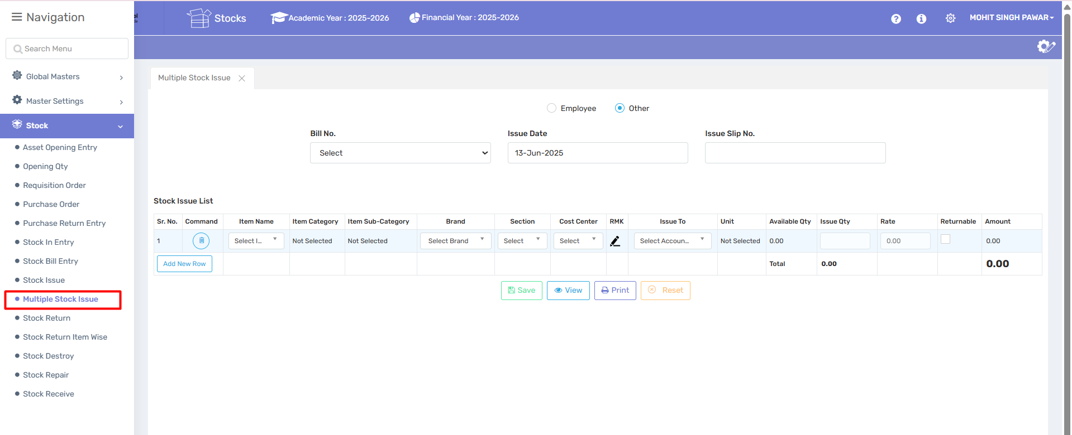

📌 Purpose:
This screen is used when you need to issue multiple items to multiple accounts/departments in one transaction. It simplifies bulk issuance and record-keeping.

🧾 Header Section:
Field | Description
Bill No. | Select or generate a bill number (usually auto-generated or linked to purchase).
Issue Date | The date on which stock is issued.
Issue Slip No. | Reference or document number for the physical issue slip.
Employee / Other | Choose if items are issued to individual employees or general accounts (e.g., departments, cost centers).

📋 Stock Issue List Table:
Each row represents one stock item being issued.
Column | Description
Sr. No. | Serial number of the row/item.
Command | Delete row if not required.
Item Name | Select the item to be issued from inventory.
Item Category / Sub-Category | Helps classify the item type.
Brand | Choose the brand/make of the item.
Section | Department associated with the issue.
Cost Center | Financial or accounting unit for tracking expense.
RMK (Remark) | Add remarks or notes per item.
Issue To | Choose the department or account the item is issued to.
Unit | Measurement unit (e.g., pcs, box, meter).
Available Qty | Current available stock in the system.
Issue Qty | Quantity to be issued.
Rate | Unit price for calculation.
Total | Auto-calculated total amount (Qty × Rate).

🛠️ Action Buttons:
Button | Function
Add New Row | Add additional items to the issue list.
💾 Save | Save the stock issue transaction.
👁️ View | View previous multiple stock issues.
🖨️ Print | Print issue slip for physical records.
✖️ Reset | Clear all entered values to start fresh.

✅ Tips:
- Use this screen when issuing many different items or items to multiple accounts at once.
- Verify stock availability before entering quantities.
- Accurate Cost Center and Section data helps in correct reporting and tracking.
- Use remarks (RMK) to capture purpose, usage, or any internal tracking notes.

3.10 Stock Return

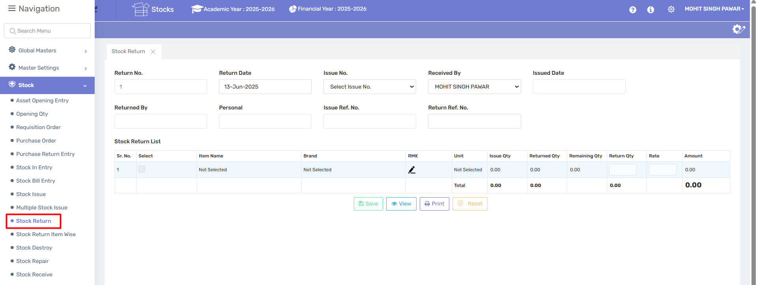

📌 Purpose:
The Stock Return screen is used to record items that are being returned from the department or employee who had previously received them through a stock issue. It helps maintain proper inventory reconciliation.

🧾 Header Section:
Field | Description
Return No. | Auto-generated or manually entered return entry number.
Return Date | Date when the item(s) are being returned.
Issue No. | Select the stock issue entry that corresponds to the return.
Received By | Person receiving the returned items (usually the store in-charge).
Issued Date | Date when the items were originally issued (auto-filled once issue no. is selected).
Returned By | Person returning the items (optional free text).
Personal | Additional info, like employee ID or name (if applicable).
Issue Ref. No. | Reference number of the original issue slip (optional).
Return Ref. No. | Reference number for this return (if any).

📋 Stock Return List Table:
Each row tracks a specific item being returned.
Column | Description
Sr. No. | Row number.
Select | Checkbox to select row for action.
Item Name | Auto-filled based on selected issue.
Brand | Brand of the item.
RMK | Remarks or reason for return.
Unit | Unit of measurement (e.g., pcs, meter).
Issue Qty | Quantity originally issued.
Returned Qty | Quantity already returned earlier (if any).
Remaining Qty | Quantity still pending return.
Return Qty | Quantity to return in this entry.
Rate | Per unit price.
Amount | Auto-calculated (Return Qty × Rate).

🛠️ Action Buttons:
Button | Function
💾 Save | Save the return transaction.
👁️ View | View previous return records.
🖨️ Print | Print the return slip for record.
✖️ Reset | Clear all input fields.

✅ Notes:
- Only items issued through the Stock Issue module can be returned here.
- The system ensures that return quantity does not exceed remaining quantity.
- Enter clear remarks in RMK to document reason or condition of returned items.
- Helps track returnable items like tools, samples, and temporary stock allocations.

3.11 Stock Return Item Wise

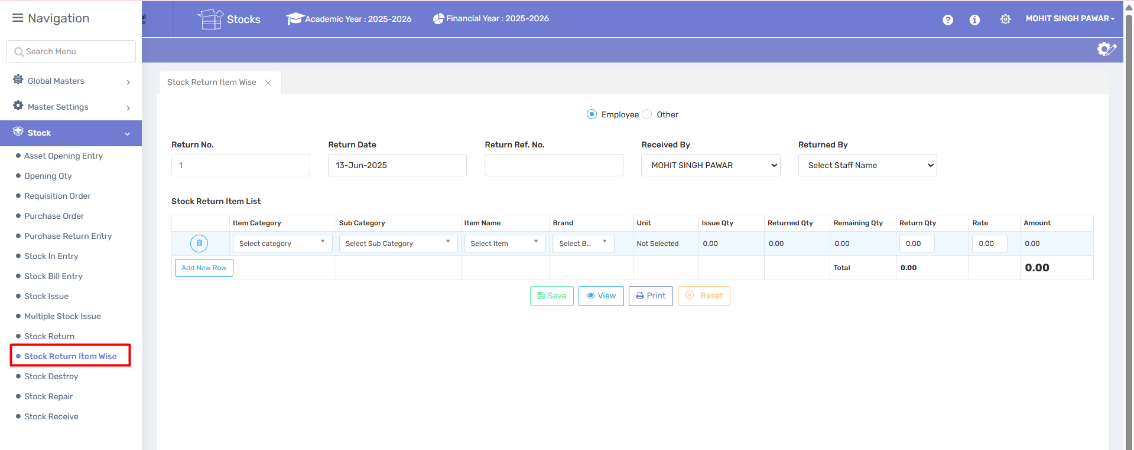

📌 Purpose:
This screen is used when an employee returns items that were issued to them. It ensures accurate stock reconciliation and tracking of issued vs. returned inventory for individuals.

🧾 Header Section:
Field | Description
Return No. | Auto-generated or manually entered unique return number.
Return Date | The date on which the items are returned.
Return Ref. No. | Optional field for internal/external reference number.
Received By | Person receiving the returned stock (typically store manager or in-charge).
Returned By | The employee who is returning the items.
Employee / Other | Choose whether the return is from an employee or an external source (like contractor, visitor, etc.).

📋 Stock Return Item List Table:
Each row records the return of a specific item.
Column | Description
Item Category | Select the category of the returned item (e.g., Stationery, Tools).
Sub Category | Select the sub-category for further classification.
Item Name | Select the specific item being returned.
Brand | Select brand (if applicable).
Unit | Unit of measurement (e.g., pieces, box).
Issue Qty | Quantity originally issued to the employee.
Returned Qty | Quantity already returned previously.
Remaining Qty | Quantity still pending to be returned.
Return Qty | Quantity being returned now.
Rate | Unit price (auto-filled or manually entered).
Amount | Auto-calculated as Return Qty × Rate.

🛠️ Action Buttons:
Button | Function
💾 Save | Save the stock return transaction.
👁️ View | View previous employee stock return records.
🖨️ Print | Generate a printable return slip.
✖️ Reset | Clear the form to default/empty state.

✅ Notes:
- Useful for returns of items such as tools, uniforms, equipment, or samples.
- Tracks accountability and ensures stock balance accuracy.
- Return quantity must not exceed remaining quantity.
- Always select the correct "Returned By" employee to maintain correct logs.

3.12 Stock Destroy

📌 Purpose:
This module is used to record damaged, expired, or unusable inventory items that must be written off and removed from stock. It helps maintain accurate inventory levels and ensures proper tracking of loss or wastage.

🧾 Header Section:
Field | Description
Destroy No. | Auto-generated or manually entered unique identifier for the destroy transaction.
Destroy Date | The date on which the stock is being destroyed.

📋 Stock Destroy List Table:
Each row documents an individual item being destroyed.
Column | Description
Sr. No. | Serial number of the row.
Command | Allows deletion of the row.
Item Name | Select the item being destroyed.
Item Category / Sub-Category | Classify the item properly.
Brand | Item brand (if applicable).
RMK | Remarks or justification for destruction (e.g., expired, damaged).
Unit | Unit of measurement (e.g., kg, pcs).
Avail Qty | Available quantity in stock.
Destroy Qty | Quantity being destroyed. Cannot exceed Available Qty.
Rate | Per unit cost of the item.
Amount | Auto-calculated as Destroy Qty × Rate.

🛠️ Action Buttons:
Button | Function
💾 Save | Save the destruction record.
👁️ View | View past stock destroy records.
🖨️ Print | Generate a printable report or slip of the destroyed stock.
✖️ Reset | Clear all fields and reset the form.

✅ Notes:
- Use this screen only after proper approval or verification of damage/expiry.
- This reduces inventory and reflects losses in stock valuation.
- For auditing, always fill in the RMK (remark) with a valid reason.
- May require documentation like photos or manager signature depending on internal policy.

3.14 Stock Repair

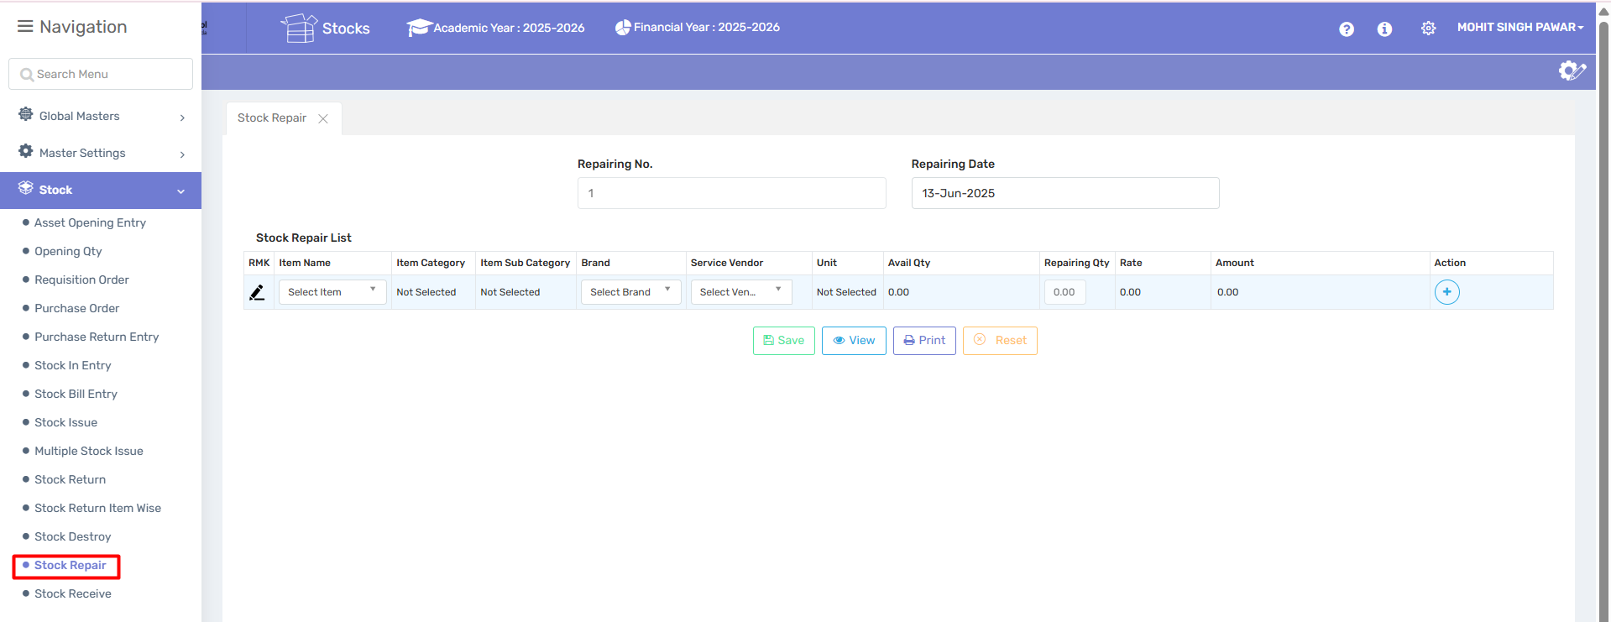

📌 Purpose:
The Stock Repair module is used to record and track items sent for repair or servicing. This ensures your stock records remain accurate and traceable even while items are temporarily unavailable due to maintenance.

🧾 Header Section:
Field | Description
Repairing No. | Unique number for each repair transaction (can be auto or manual).
Repairing Date | The date the item was sent for repair.

📋 Stock Repair List Table:
Each row records one item being sent for repair.
Column | Description
RMK | Remarks on the reason for repair (e.g., malfunction, routine service).
Item Name | Select the item being sent for repair.
Item Category / Sub-Category | Classify the item.
Brand | Item brand, if applicable.
Service Vendor | Select the vendor responsible for the repair work.
Unit | Unit of measurement (pcs, kg, etc.).
Avail Qty | Quantity currently available in inventory.
Repairing Qty | Quantity being sent for repair.
Rate | Estimated or known rate of the item.
Amount | Auto-calculated as Repairing Qty × Rate.
Action | Add or delete row entry.

🛠️ Action Buttons:
Button | Function
💾 Save | Save the repair entry.
👁️ View | View existing repair transactions.
🖨️ Print | Print the repair entry details.
✖️ Reset | Clear the current form inputs.

✅ Notes:
- Use the Service Vendor dropdown to select an approved repair provider.
- Ensure that repairing quantity does not exceed available stock.
- Optionally link with Repair Return module when items come back post-service.
- Fill RMK with valid service justification to ensure audit readiness.

3.15 Stock Receive
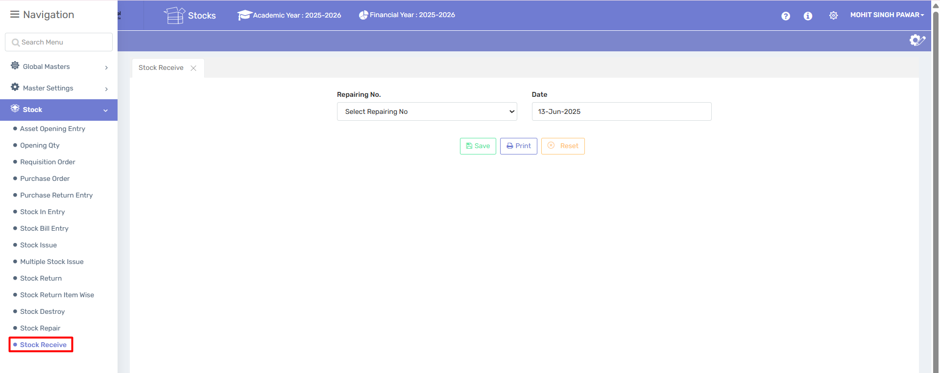

📌 Purpose:
The Stock Receive module is used to acknowledge and record the receipt of items that were sent for repair. It updates the stock levels and marks the completion of the repair cycle for those items.

🧾 Fields & Description:
Field | Description
Repairing No. | Select the corresponding Repairing Number from the list. This links the stock receive entry to a previously recorded repair.
Date | The date the repaired item is received back into stock.

🛠️ Action Buttons:
Button | Function
💾 Save | Confirms and saves the receipt entry of the repaired item.
🖨️ Print | Allows printing the stock receipt record for physical filing.
✖️ Reset | Clears all current selections on the form.

✅ Notes:
- You must select a valid Repairing No. that has already been saved in the Stock Repair screen.
- Stock quantities will be automatically adjusted based on the repairing quantity returned.
- Ensure the return is logged on the actual date of receipt for accurate inventory tracking.
- This screen doesn't show line items directly—it's a confirmation module based on prior Repair entries.

3.16 Assets Verification

3.16.1 Item Details entry

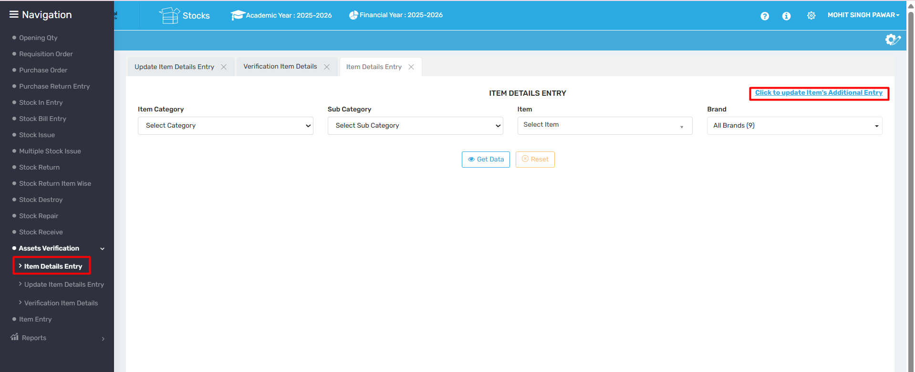

📌 Purpose:
The Item Details Entry screen is used to view, filter, and update details of existing stock items based on category, sub-category, item name, and brand. It helps manage item configurations and perform additional data entries like specifications, descriptions, or linked attributes.

🧾 Fields & Descriptions:
Field | Description
Item Category | Select the main category of the item (e.g., Electrical, Furniture, etc.).
Sub Category | Select the sub-category related to the selected item category.
Item | Select the specific item whose details you want to fetch or update.
Brand | Filter by a specific brand, or choose “All Brands” to include all variations.

🔘 Buttons:
Button | Function
👁️ Get Data | Fetches and displays item details based on selected filters.
✖️ Reset | Clears all selected fields and restores default view.
🔗 Click to update Item’s Additional Entry | Opens a new screen or form for adding or editing additional attributes or data linked to the selected item (e.g., warranty, barcode, dimensions).

✅ Notes:
- Useful for auditing item configurations and making batch updates.
- You must select valid values for Category, Sub Category, and Item to proceed.
- The “Additional Entry” link is often used to record custom item specifications required for specific departments or functions.

3.16.2 Update Item Details Entry

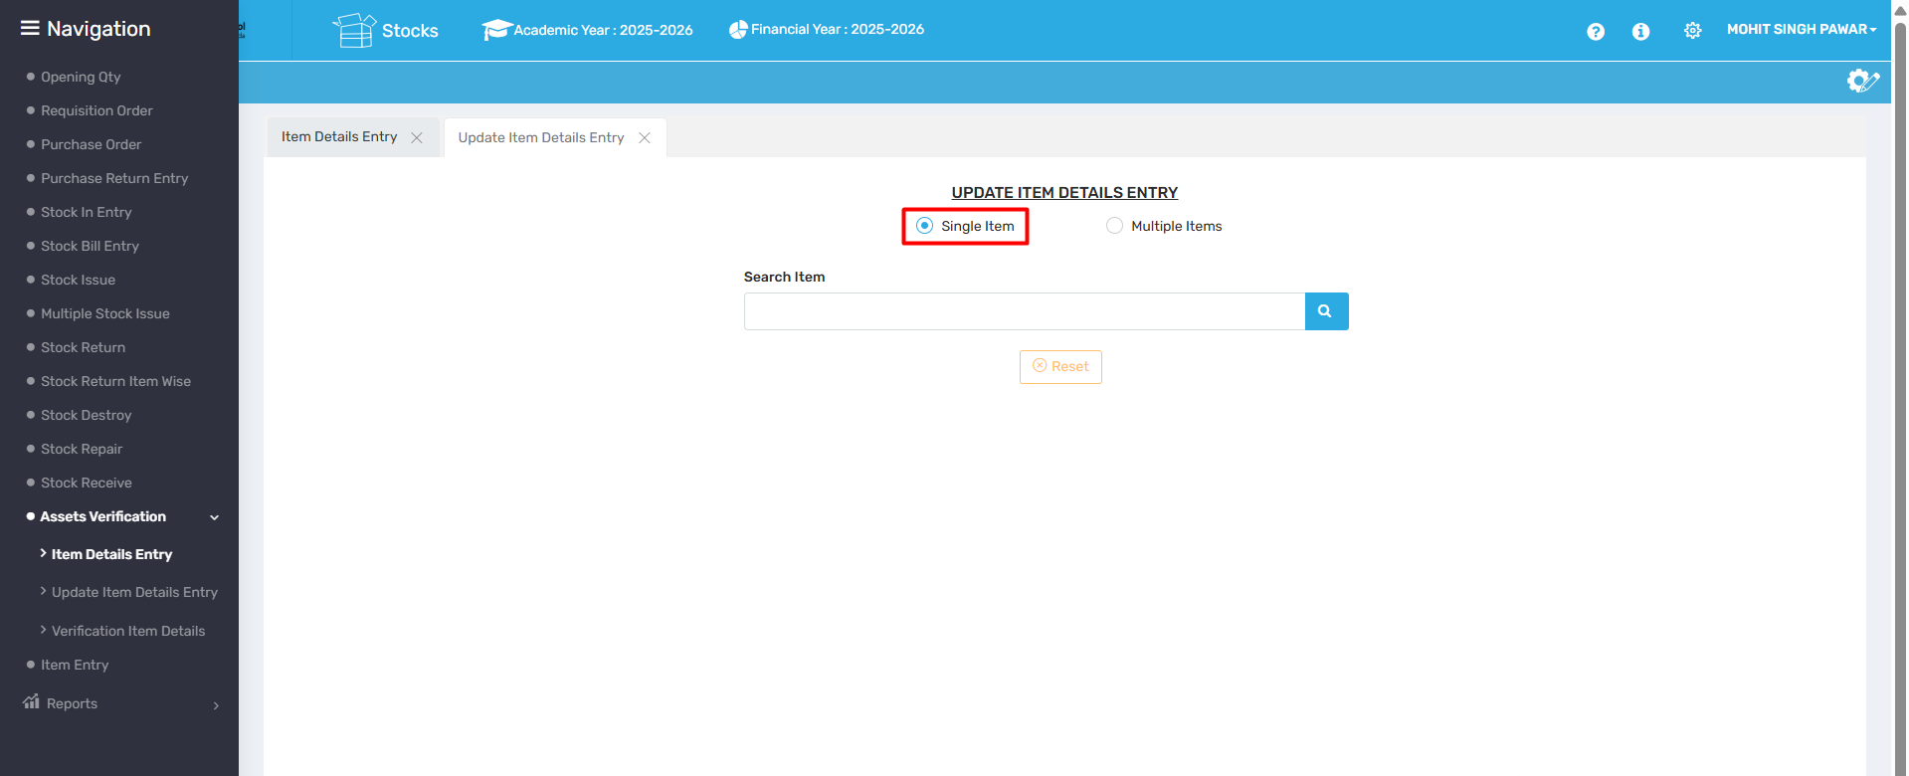

📌 Purpose:
The Update Item Details Entry screen is used to modify existing item information in bulk or individually. This allows quick updates to inventory records such as specifications, properties, or settings linked to stock items.

🧾 Fields & Options:
Field | Description
Single Item / Multiple Items | Choose whether to update one specific item or perform a batch update on multiple items.
Item Category | Select the main category (e.g., Electronics, Furniture) of items you want to update.
Sub Category | Choose the relevant sub-category based on your selected item category.
Item | If "Single Item" is selected, choose the specific item to update. If "Multiple Items" is selected, this may be disabled or used as a filter.
Brand | Filter items by brand, or select “All Brands” to view every available option.

🔘 Buttons:
Button | Function
👁️ Get Data | Fetches a list of items (or the selected item) to be updated.
✖️ Reset | Clears all selected filters and fields.

✅ Notes:
- When Multiple Items is selected, you can apply changes in bulk (e.g., assigning a new vendor or updating unit of measure).
- Ensure correct filters are selected to avoid unwanted updates to unintended items.
- Use this screen responsibly, especially in live inventory systems, to avoid data inconsistencies.
3.16.3Verification Item Details

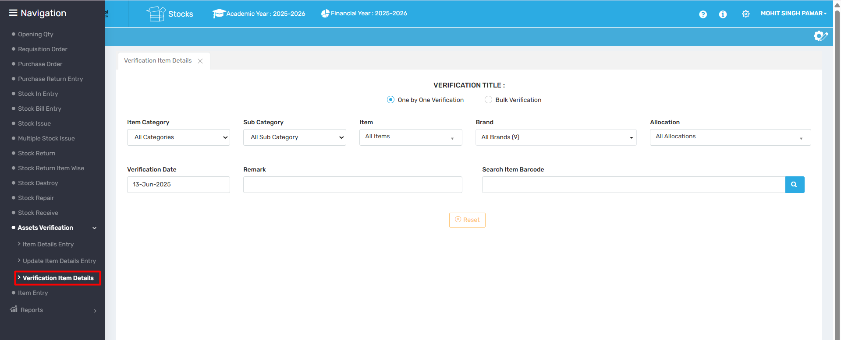

📌 Purpose:
The Verification Item Details screen is used to verify stock items either one-by-one or through bulk verification. This is typically used during audits, physical stock checking, or item barcode validation.

🧾 Fields & Options:
Field | Description
Verification Title | A label (e.g. "TESTING") indicating the purpose or session name for the stock check.
One by One Verification / Bulk Verification | Choose how the verification will be done: individually or in bulk.
Item Category | Filter by the item’s main category.
Sub Category | Further filter based on sub-categories of items.
Item | Select a specific item to verify or keep it as "All Items" for broader filtering.
Brand | Filter items by brand.
Allocation | Choose a specific allocation/location for item verification (e.g., Department, Store Room).
Verification Date | Date when the verification is taking place.
Remark | Field to enter any observation or comment during verification.
Search Item Barcode | Scan or manually enter the item barcode to verify.

🔘 Button:
Button | Function
🔍 (Search) | Initiates search of item based on barcode.
✖️ Reset | Clears all filters and input fields.

✅ Notes:
- One by One Verification allows tracking and commenting on each item individually.
- Bulk Verification is useful for mass updates or reconciliations.
- Always double-check filters before scanning barcodes to ensure accurate validation context.

3.17 Item Entry

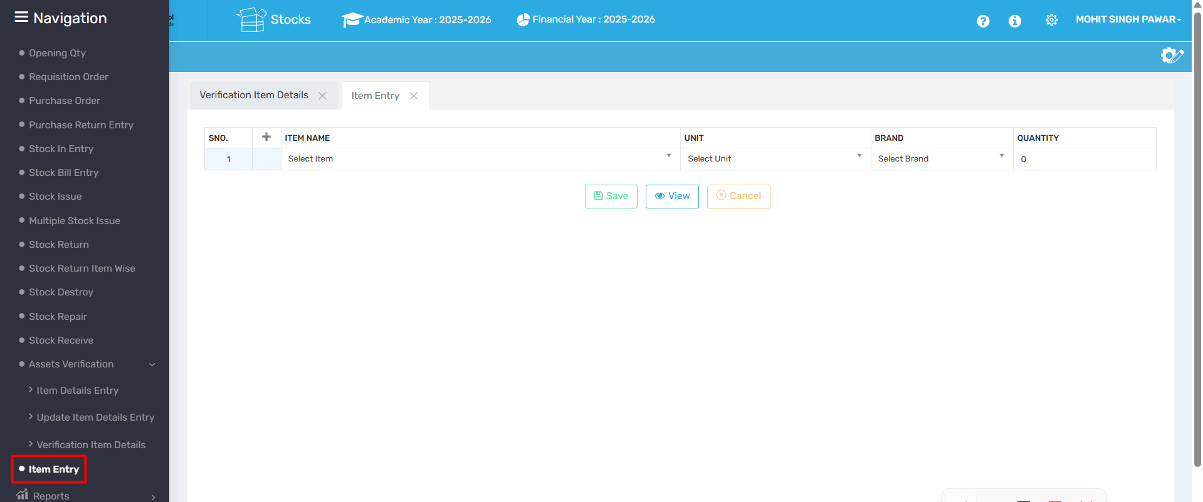

📌 Purpose:
The Item Entry screen is used to manually add new stock items into the inventory system. This is useful for first-time entries, new arrivals, or stock adjustments.

🧾 Fields & Their Purpose:
Field | Description
S.No. | Serial number for the entry (auto-generated).
Item Name | Dropdown to select the item you want to enter into the system.
Unit | Measurement unit (e.g., pcs, liters, kg) for the selected item.
Brand | Brand associated with the item, useful for tracking and categorization.
Quantity | Quantity of the item to be added. Default is 0; update before saving.

🔘 Button Actions:
Button | Function
✅ Save | Saves the entered item(s) into the inventory.
👁️ View | Displays all current item entries in the system.
✖️ Cancel | Clears the form or cancels the entry process.

🔄 Additional Features:
- You can click the + icon in the header to add more rows for multiple item entries at once.
- Useful for bulk manual entries during opening stock setup or direct purchases.

